Errrrrrrrrrrer

MS Visual Arts (6-8)

http://grading.dmschools.org
http://visualarts.dmschools.org/middle-school.html

Foreword
- Foreword includes purpose as well as what can be expected from the guide. (How to use this document…)
- Explains what expectations are for teacher action
How to use this document:
This curriculum guide is not… (determined by specific curriculum phase)
- A lock-step instructional guide detailing exactly when and how you teach.
- Meant to restrict your creativity as a teacher.
- A ceiling of what your students can learn, nor a set of unattainable goals.
Instead, the curriculum guide is meant to be a common vision for student learning and a set of targets and success criteria directed related to grade-level standards by which to measure and report student progress and provide meaningful feedback.
The curriculum guide outlines the learning that is most essential for student success; it is our district’s guaranteed and viable curriculum. The expectation is that every student in our district, regardless of school or classroom, will have access to and learn these targets. As the classroom teacher, you should use the curriculum guide to help you to decide how to scaffold up to the learning targets and extend your students’ learning beyond them.
Within this document, you will find a foundational structure for planning sequential instruction in the classroom which can be supplemented with materials from any number of the linked resources.
Please consider this guide a living and dynamic document, subject to change and a part of a continuous feedback loop.

Visual Art Middle School (6-8): Year at a Glance
This course provides middle school students the opportunity to explore their own art-making using the creative process while connecting their ideas to wider contexts including the ethical responsibilities of an artist and how art is influenced by the time, place, and context in which it was created. Students explore these ideas in each middle school grade level for a nine-week period using a variety of topics and projects determined by the visual art teacher.
Primary Resources: Learning Targets are linked below each unit scale. These include all required sources for the course.
Supplemental Texts =
Semester 1 | Topic: Creating | Topic: Connecting | Topic: Responding
Reporting frequency of topic scores | 9 weeks of content  Each unit should include LTs from Creating and an LT from Connecting or Responding  Optional 9-week scope and sequence
Approximate beginning and end dates for the topics
(optional)
Standards Aligned | Anchor Standard1: Generate and conceptualize artistic ideas and work.  Anchor Standard 2: Organize and develop artistic ideas and work. | Anchor Standard 10: Synthesize and relate knowledge and personal experiences to make art. | Anchor Standard 9: Apply criteria to evaluate artistic work.

Evidence shows the student can... | Topic Score
Demonstrates proficiency (AT) in all learning targets from Level 3 & Level 4 | 4.0
Demonstrates proficiency (AT) in all learning targets from Level 3 with partial success at Level 4 | 3.5
Demonstrates proficiency (AT) in all learning targets from Level 3 | 3.0
Demonstrates proficiency (AT) in at least half of the Level 3 learning targets | 2.5
Demonstrates some foundational knowledge (PT) toward all Level 3 targets | 2.0
Demonstrates some foundational knowledge (PT) of some of the Level 3 learning target or standard | 1.5
Does not meet minimum criteria for the standard or target. | 1.0
Produces no evidence appropriate to the learning targets at any level (Is missing for one or more targets) | 0
* foundational knowledge is defined by the success criteria for the learning targets or standards.

Standards-Referenced Grading Basics
Our purpose in collecting a body of evidence is to:
• Allow teachers to determine a defensible and credible topic score based on a
Start at Level 3 when determining a topic → score.
representation of student learning over time.
• Clearly communicate where a student’s learning is based on a topic scale to
inform instructional decisions and push student growth.
• Show student learning of Level 3 targets through multiple and varying points of data
• Provide opportunities for feedback between student and teacher.

Scoring
A collaborative scoring process is encouraged to align expectations of the scale to artifacts collected. Routine use of a collaborative planning and scoring protocol results in calibration and a collective understanding of evidence of mastery. Enough evidence should be collected to accurately represent a progression of student learning as measured by the topic scale. Teachers look at all available evidence to determine a topic score. All topic scores should be defensible and credible through a body of evidence.
***Only scores of 4, 3.5, 3, 2.5, 2, 1.5, 1, and 0 can be entered as Topic Scores.
Guiding Practices of Standards-Referenced Grading
- A consistent 4-point grading scale will be used.
- Student achievement and behavior will be reported separately.
- Scores will be based on a body of evidence.
- Achievement will be organized by learning topic and converted to a grade at semester’s end.
- Students will have multiple opportunities to demonstrate proficiency.
- Accommodations and modifications will be provided for exceptional learners.

Multiple Opportunities
Philosophically, there are two forms of multiple opportunities, both of which require backwards design and intentional planning. One form is opportunities planned by the teacher throughout the unit of study and/or throughout the semester. The other form is reassessment of learning which happens after completing assessment of learning at the end of a unit or chunk of learning.
Students will be allowed multiple opportunities to demonstrate proficiency. Teachers need reliable pieces of evidence to be confident students have a good grasp of the learning topics before deciding a final topic score. To make standards-referenced grading work, the idea of “multiple opportunities” is emphasized. If after these opportunities students still have not mastered Level 3, they may then be afforded the chance to reassess.

Anatomy of a Scale
Unit Narrative:
Provide an overview and context of the unit, big understandings, and student experience—including by not limited to vocabulary, inquiry-based questions/concepts, pacing and number of lessons
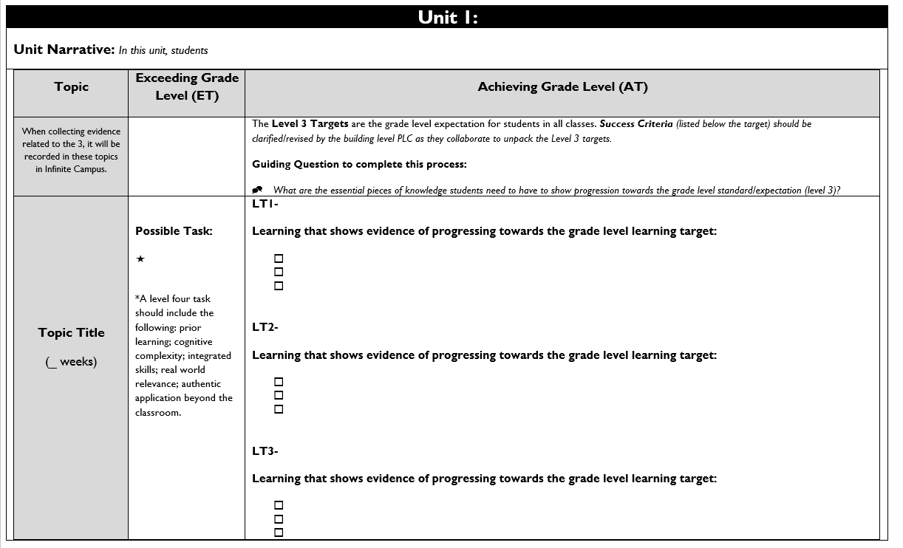

Topic Title:
Named topic in infinite campus, with approximate number of paced weeks
Exceeding Grade Level (ET):
Possible level four task listed including prior learning, cognitive complexity, integrated skills, real world relevance: authentic application beyond the classroom.

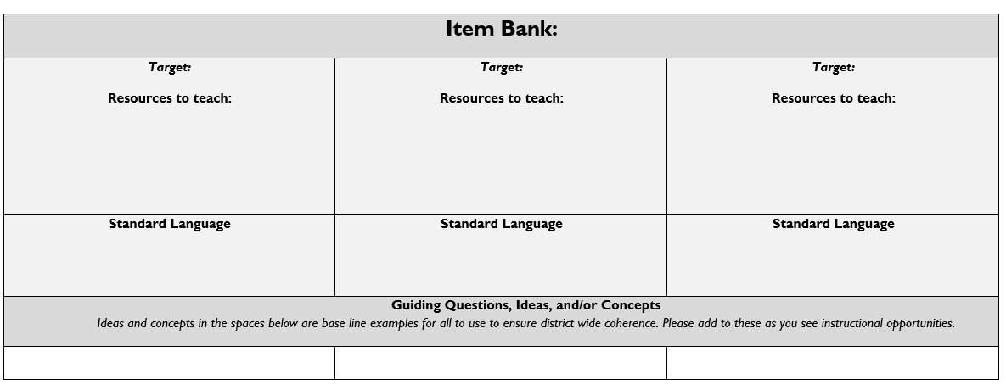
Achieving Grade Level
(AT):
Level 3 targets are listed within the topic scale and are the grade level expectation for students in all classes.
Success Criteria (listed below the target) should be clarified/revised by the building level PLC as they collaborate to unpack the Level 3 targets.

Item Bank:
Linked resources for each learning target. Guiding/Inquiry questions, ideas, and/or concepts are below the base line examples to ensure district wide coherence.

{Optional Page for Content Area Vertical Alignment K-12} (Course pathway to be created by media team and uploaded here)

Topic: Creating
Unit Narrative/Overview: In this topic, students develop their artistic skills through the creative process. The creative process includes brainstorming and sketching ideas that match a creative problem, developing skills using a variety of media, refining artwork to meet the intended goal, and evaluating artwork based upon determined criteria.
Creating: PK-12 Anchor Standard 1: Generate and conceptualize artistic ideas and work.
Creating: PK-12 Anchor Standard 2: Organize and develop artistic ideas and work.
Topic | Exceeding Grade Level (ET) | Achieving Grade Level (AT)
When collecting evidence related to the 3, it will be recorded in these topics in Infinite Campus. | {Optional Column} | The Level 3 Targets are the grade level expectation for students in all classes. Success Criteria (listed below the target) should be clarified/revised by the building level PLC as they collaborate to unpack the Level 3 targets.  Guiding Question to complete this process:  - What are the essential pieces of knowledge students need to have to show progression towards the grade-level standard/expectation (level 3)?
Creating | Possible Task:  *A level four task should include the following: prior learning; cognitive complexity; integrated skills; real world relevance; authentic application beyond the classroom. | LT1A- I can document the early stages of the creative process.  Learning that shows evidence of progressing towards grade-level learning target:  - I can identify and define the 4 steps of the creative process.  - I can illustrate the creative process.  - I can communicate the process visually or verbally.  - I can use a variety of materials, both traditional and nontraditional.  LT1B- I can develop criteria that guide my artmaking.  Learning that shows evidence of progressing towards grade-level learning target:  - I can explain the difference between personal criteria and established criteria.  - I can determine what personal and established criteria I plan to include in my artmaking.  - I can identify mediums that will help me be successful with my art.  LT1C- I can demonstrate openness to trying new ideas, materials, and approaches in making art.  Learning that shows evidence of progressing towards grade-level learning target:  - I can explore multiple mediums and techniques to create art.  - I can brainstorm multiple art-making ideas.  - I can apply new ideas and approaches to my art.  LT1D- I can demonstrate awareness of ethical responsibility to myself and others when sharing or posting content.  Learning that shows evidence of progressing towards grade-level learning target:  - I can identify the impact of ethics in art through processing and discussion.  - I can communicate key considerations when posting content on the internet.  - I can plan my idea so that it is ethically responsible to my audience.  LT1E- I can apply visual organizational strategies to design and produce a work of art to clearly communicate information or ideas.  Learning that shows evidence of progressing towards grade-level learning target:  - I can identify the elements of art and principles of design.  - I can determine if the use of an element of art or principle of design is successful and explain why.  - I can apply accurate use of an element of art and/or principle(s) of design in my original artwork.
Item Bank:
Creating: PK-12 Anchor Standard 1: Generate and conceptualize artistic ideas and work. |  | Creating: PK-12 Anchor Standard 2: Organize and develop artistic ideas and work.
1ATarget: I can document the early stages of the creative process.  Resources to teach:  6th Grade Canvas Course  7th Grade Canvas Course  8th Grade Canvas Course | 1BTarget: I can develop criteria that guide my artmaking.  Resources to teach:  6th Grade Canvas Course  7th Grade Canvas Course  8th Grade Canvas Course | 1CTarget: I can demonstrate openness to trying new ideas, materials, and approaches in making art.  Resources to teach:  6th Grade Canvas Course  7th Grade Canvas Course  8th Grade Canvas Course | 1DTarget: I can demonstrate awareness of ethical responsibility to myself and others when sharing or posting content.  Resources to teach:  6th Grade Canvas Course  7th Grade Canvas Course  8th Grade Canvas Course | 1ETarget: I can apply visual organizational strategies to design and produce a work of art to clearly communicate information or ideas.  Resources to teach:  6th Grade Canvas Course  7th Grade Canvas Course  8th Grade Canvas Course
Standard Language  Document early stages of the creative process visually and/or verbally in traditional or nontraditional materials (VA:Cr1.1.8a) | Standard Language  Develop criteria to guide making a work of art or design to meet an identified goal (VA:Cr1.2.7a) | Standard Language  Demonstrate openness in trying new ideas, materials, methods, and approaches in making works of art and design (VA:Cr2.1.6a) | Standard Language  Demonstrate awareness of ethical responsibility to oneself and others when posting and sharing images and other materials through the internet, social media, and other communication formats. (VA:Cr2.2.7a) | Standard Language  Apply visual organizational strategies to design and produce a work of art, design, or media that clearly communicates information or ideas (VA:Cr2.3.7a)
Guiding Questions, Ideas, and/or Concepts
Ideas and concepts in the spaces below are base line examples for all to use to ensure district wide coherence. Please add to these as you see instructional opportunities.
Enduring Understanding:  - Creativity and innovative thinking are essential life skills that can be developed.  - Artists and designers shape artistic investigations, following or breaking with traditions in pursuit of creative artmaking goals.  Essential Question(s):  - What conditions, attitudes, and behaviors support creativity and innovative thinking?  - What factors prevent or encourage people to take creative risks? How does collaboration expand the creative process?  - How does knowing the contexts histories, and traditions of art forms help us create works of art and design?  - Why do artists follow or break from established traditions?  - How do artists determine what resources and criteria are needed to formulate artistic investigations? |  | Enduring Understanding:  - Artists and designers’ experiment with forms, structures, materials, concepts, media, and art-making approaches.  - Artists and designers balance experimentation and safety, freedom and responsibility while developing and creating artworks.  - People create and interact with objects, places, and designs that define, shape, enhance, and empower their lives.  Essential Question(s):  - How do artists work?  - How do artists and designers determine whether a particular direction in their work is effective?  - How do artists and designers learn from trial and error?  - How do artists and designers care for and maintain materials, tools, and equipment?  - Why is it important for safety and health to understand and follow correct procedures in handling materials, tools, and equipment?  - What responsibilities come with the freedom to create?  - How do objects, places, and design shape lives and communities?  - How do artists and designers determine goals for designing or redesigning objects, places, or systems?  - How do artists and designers create works of art or design that effectively communicate?

Topic: Connecting
Unit Narrative/Overview: In this topic, students will relate artwork and artmaking to other contexts including how art is influenced by time, place, society, and culture.
Connecting: PK-12 Anchor Standard 10: Synthesize and relate knowledge and personal experiences to make art
Topic | Exceeding Grade Level (ET) | Achieving Grade Level (AT)
When collecting evidence related to the 3, it will be recorded in these topics in Infinite Campus. | {Optional Column} | The Level 3 Targets are the grade-level expectation for students in all classes. These are directly related to State of Iowa standards.  Success Criteria (listed below the target) should be clarified/revised by the building level PLC as they collaborate to unpack the Level 3 targets.  Guiding Question to complete this process:  - What are the essential pieces of knowledge students need to have to show progression towards the grade level standard/expectation (level 3)?
Connecting | In addition to meeting the entire learning goal (all learning targets in a topic), a connection is made to one or more of the following:  Possible Task: | LT2A- I can analyze how the response to art is influenced by an understanding of the context in which it was created.  Learning that shows evidence of progressing towards grade-level learning target:  - I can define what art is.  - I can identify ways art helps us understand society, culture, and/or history.  - I can identify examples of how and why art has been influenced by society.  - I can form a supported opinion of the intended meaning of an artwork using contextual factors.

Item Bank:
2ATarget: I can analyze how the response to art is influenced by an understanding of the context in which it was created.
Resources to teach:
6th Grade Canvas Course
7th Grade Canvas Course
8th Grade Canvas Course

Standard Language
Connecting: PK-12 Anchor Standard 10: Synthesize and relate knowledge and personal experiences to make art.
Analyze how response to art is influenced by understanding the time and place in which is was created, the available resources, and cultural uses.
Guiding Questions, Ideas, and/or Concepts
Ideas and concepts in the spaces below are base line examples for all to use to ensure district wide coherence. Please add to these as you see instructional opportunities.
Enduring Understanding:
- Through art-making, people make meaning by investigating and developing awareness of perceptions, knowledge, and experiences.
Essential Question(s):
- How does engaging in creating art enrich people’s lives?
- How does making art attune people to their surroundings?
- How do people contribute to awareness and understanding of their lives and the lives of their communities through art-making?

Topic: Responding
Unit Narrative/Overview: In this topic, Students will explore evaluating artwork using different sets of criteria.
Responding: PK-12 Anchor Standard 9: Apply criteria to evaluate artistic work.
Topic | Exceeding Grade Level (ET) | Achieving Grade Level (AT)
When collecting evidence related to the 3, it will be recorded in these topics in Infinite Campus. | {Optional Column} | The Level 3 Targets are the grade level expectation for students in all classes. These are directly related to State of Iowa standards.  Success Criteria (listed below the target) should be clarified/revised by the building level PLC as they collaborate to unpack the Level 3 targets.  Guiding Question to complete this process:  - What are the essential pieces of knowledge students need to have to show progression towards the grade level standard/expectation (level 3)?
Responding | In addition to meeting the entire learning goal (all learning targets in a topic), a connection is made to one or more of the following: a development from a different historical period, era, or place or a course theme that is not the current focus.  Possible Task: | LT3A- I can compare and explain personal criteria and established criteria and apply them to multiple artworks.  Learning that shows evidence of progressing towards grade-level learning target:  - I can explain the differences between personal criteria and established criteria.  - I can apply personal criteria to a work of art.  - I can apply established criteria to a work of art.

Item Bank:
3ATarget: I can compare and explain personal criteria and established criteria and apply them to multiple artworks.
Resources to teach:
6th Grade Canvas Course
7th Grade Canvas Course
8th Grade Canvas Course

Standard Language
Responding: PK-12 Anchor Standard 9: Apply criteria to evaluate artistic work.
Compare and explain the difference between an evaluation of an artwork based on personal criteria and an evaluation of an artwork based on a set of established criteria
Guiding Questions, Ideas, and/or Concepts
Ideas and concepts in the spaces below are base line examples for all to use to ensure district wide coherence. Please add to these as you see instructional opportunities.
Enduring Understanding:
- People evaluate art based on various criteria
Essential Question(s):
- How does one determine criteria to evaluate a work of art?
- How and why might criteria vary?
- How is a personal preference different from an evaluation?

