Errrrrrrrrrrer

Intro to 2D Art & 3D Art
ART101 & ART102

http://grading.dmschools.org
http://visualarts.dmschools.org

Foreword
- Foreword includes purpose as well as what can be expected from the guide. (How to use this document…)
- Explains what expectations are for teacher action
How to use this document:
This curriculum guide is not… (determined by specific curriculum phase)
- A lock-step instructional guide detailing exactly when and how you teach.
- Meant to restrict your creativity as a teacher.
- A ceiling of what your students can learn, nor a set of unattainable goals.
Instead, the curriculum guide is meant to be a common vision for student learning and a set of targets and success criteria directed related to grade-level standards by which to measure and report student progress and provide meaningful feedback.
The curriculum guide outlines the learning that is most essential for student success; it is our district’s guaranteed and viable curriculum. The expectation is that every student in our district, regardless of school or classroom, will have access to and learn these targets. As the classroom teacher, you should use the curriculum guide to help you to decide how to scaffold up to the learning targets and extend your students’ learning beyond them.
Within this document, you will find a foundational structure for planning sequential instruction in the classroom which can be supplemented with materials from any number of the linked resources.
Please consider this guide a living and dynamic document, subject to change and a part of a continuous feedback loop.

(Name of Course): Year at a Glance
[Course Narrative]
Primary Resources: Learning Targets are linked below each unit scale. These include all required sources for the course.
Supplemental Texts =
Semester 1 | Topic 1: Creating  S1 Canvas | Topic 2: Connecting  S1 Canvas | Topic 3: Responding  S1 Canvas
Reporting frequency of topic scores | # of weeks | # of weeks | # of weeks
Approximate beginning and end dates for the topics
(optional)
Standards Aligned | Anchor Standards Creating 2 & 3 | Anchor Standard Connecting 10 | Anchor Standard Responding 9

Semester 2 | Topic 1: Creating  S2 Canvas | Topic 2: Connecting  S2 Canvas | Topic 3: Responding  S2 Canvas
Reporting frequency of topic scores | # of weeks | # of weeks | # of weeks
Approximate beginning and end dates for the topics
(optional)
Standards Aligned | Anchor Standards Creating 2 & 3 | Anchor Standard Connecting 10 | Anchor Standard Responding 9

Evidence shows the student can... | Topic Score
Demonstrates proficiency (AT) in all learning targets from Level 3 & Level 4 | 4.0
Demonstrates proficiency (AT) in all learning targets from Level 3 with partial success at Level 4 | 3.5
Demonstrates proficiency (AT) in all learning targets from Level 3 | 3.0
Demonstrates proficiency (AT) in at least half of the Level 3 learning targets | 2.5
Demonstrates some foundational knowledge (PT) toward all Level 3 targets | 2.0
Demonstrates some foundational knowledge (PT) of some of the Level 3 learning target or standard | 1.5
Does not meet minimum criteria for the standard or target. | 1.0
Produces no evidence appropriate to the learning targets at any level (Is missing for one or more targets) | 0
* foundational knowledge is defined by the success criteria for the learning targets or standards.

Standards-Referenced Grading Basics
Our purpose in collecting a body of evidence is to:
• Allow teachers to determine a defensible and credible topic score based on a representation of student learning over time.
Start at Level 3 when determining a topic → score.
• Clearly communicate where a student’s learning is based on a topic scale to inform instructional decisions and push student growth.
• Show student learning of Level 3 targets through multiple and varying points of data
• Provide opportunities for feedback between student and teacher.
Scoring
A collaborative scoring process is encouraged to align expectations of the scale to artifacts collected. Routine use of a collaborative planning and scoring protocol results in calibration and a collective understanding of evidence of mastery. Enough evidence should be collected to accurately represent a progression of student learning as measured by the topic scale. Teachers look at all available evidence to determine a topic score. All topic scores should be defensible and credible through a body of evidence.
***Only scores of 4, 3.5, 3, 2.5, 2, 1.5, 1, and 0 can be entered as Topic Scores.
Guiding Practices of Standards-Referenced Grading
- A consistent 4-point grading scale will be used.
- Student achievement and behavior will be reported separately.
- Scores will be based on a body of evidence.
- Achievement will be organized by learning topic and converted to a grade at semester’s end.
- Students will have multiple opportunities to demonstrate proficiency.
- Accommodations and modifications will be provided for exceptional learners.

Multiple Opportunities
Philosophically, there are two forms of multiple opportunities, both of which require backwards design and intentional planning. One form is opportunities planned by the teacher throughout the unit of study and/or throughout the semester. The other form is reassessment of learning which happens after completing assessment of learning at the end of a unit or chunk of learning.
Students will be allowed multiple opportunities to demonstrate proficiency. Teachers need reliable pieces of evidence to be confident students have a good grasp of the learning topics before deciding a final topic score. To make standards-referenced grading work, the idea of “multiple opportunities” is emphasized. If after these opportunities students still have not mastered Level 3, they may then be afforded the chance to reassess.

Anatomy of a Scale
Unit Narrative:
Provide an overview and context of the unit, big understandings, and student experience—including by not limited to vocabulary, inquiry-based questions/concepts, pacing and number of lessons
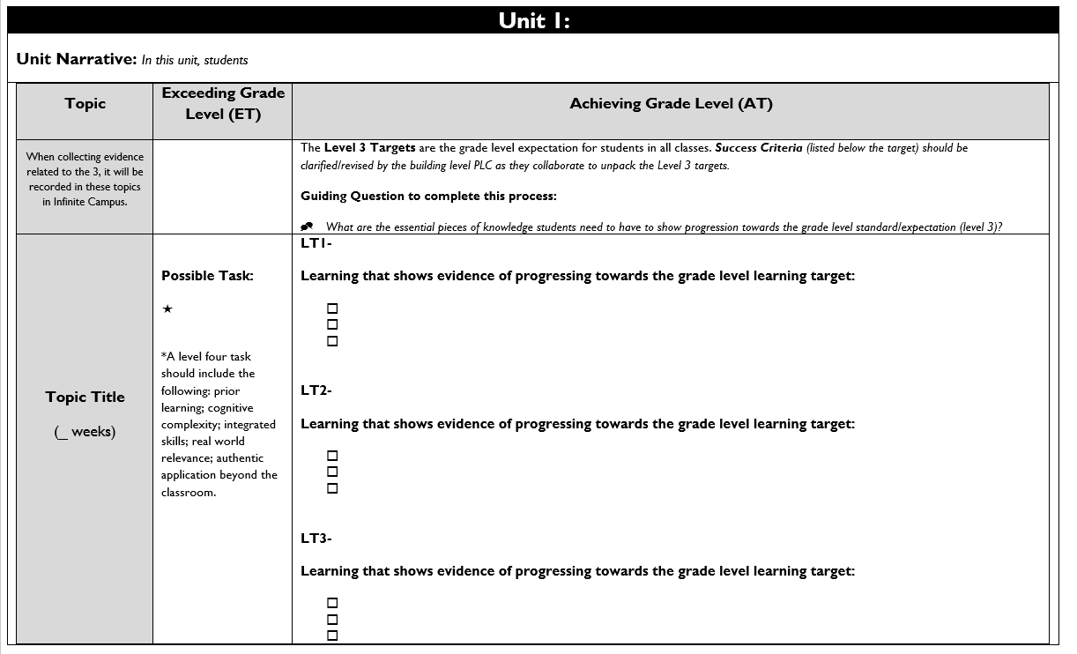

Topic Title:
Named topic in infinite campus, with approximate number of paced weeks
Exceeding Grade Level (ET):
Possible level four task listed including prior learning, cognitive complexity, integrated skills, real world relevance: authentic application beyond the classroom.

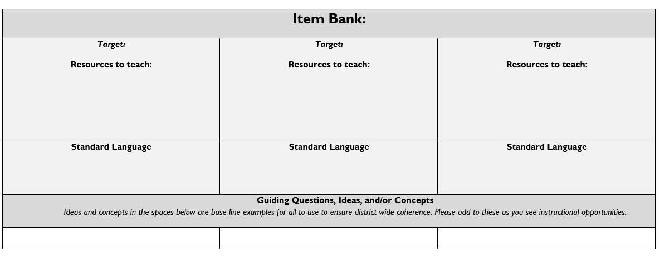
Achieving Grade Level
(AT):
Level 3 targets are listed within the topic scale and are the grade level expectation for students in all classes.
Success Criteria (listed below the target) should be clarified/revised by the building level PLC as they collaborate to unpack the Level 3 targets.

Item Bank:
Linked resources for each learning target. Guiding/Inquiry questions, ideas, and/or concepts are below the base line examples to ensure district wide coherence.

{Optional Page for Content Area Vertical Alignment K-12}

Topic 1: Creating
Unit Narrative/Overview: In this topic, students will…
Creating: PK-12 Anchor Standard 2: Organize and develop artistic ideas and work.
Creating: PK-12 Anchor Standard 3: Refine and complete artistic work.
Topic | Exceeding Grade Level (ET) | Achieving Grade Level (AT)
When collecting evidence related to the 3, it will be recorded in these topics in Infinite Campus. | {Optional Column} | The Level 3 Targets are the grade level expectation for students in all classes. Success Criteria (listed below the target) should be clarified/revised by the building level PLC as they collaborate to unpack the Level 3 targets.  Guiding Question to complete this process:  - What are the essential pieces of knowledge students need to have to show progression towards the grade-level standard/expectation (level 3)?
Creating | Possible Task:  *A level four task should include the following: prior learning; cognitive complexity; integrated skills; real world relevance; authentic application beyond the classroom. | LT1A- Through experimentation, practice, and persistence demonstrate the acquisition of skills and knowledge in a chosen art form.  Learning that shows evidence of progressing towards grade-level learning target:  - Experiment and practice skills and techniques with a variety of media.  - Review and reflect on your practice work and select the material and technique you mastered  - Create an original artwork using your chosen material.  LT1B- Engage in constructive critique with peers, then reflect, revise, and refine works of art and design in response to personal artistic vision as it pertains to visual art criteria.  Learning that shows evidence of progressing towards grade-level learning target:  - Analyze and provide feedback on a peer’s artwork.  - Reflect on peer feedback along with personal review of visual art criteria to determine if your works needs revision.  - Refine artwork with suggested and chosen changes.
Item Bank:
1ATarget: Through experimentation, practice, and persistence demonstrate the acquisition of skills and knowledge in a chosen art form.  Resources to teach: | 1BTarget: Engage in constructive critique with peers, then reflect, revise, and refine works of art and design in response to personal artistic vision as it pertains to visual art criteria.  Resources to teach:
Standard Language  Through experimentation, practice and persistence, demonstrate acquisition of skills and knowledge in a chosen art form. (VA: Cr2.1.IIa) | Standard Language  Engage in constructive critique with peers, then reflect on, re-engage, revise, and/or refine works of art and design in response to personal artistic vision as it pertains to visual art criteria. (VA:Cr3.1.IIa)
Guiding Questions, Ideas, and/or Concepts
Ideas and concepts in the spaces below are base line examples for all to use to ensure district wide coherence. Please add to these as you see instructional opportunities.
Enduring Understanding:  Artists and designers experiment with forms, structures, materials, concepts, media, and art-making approaches.  Essential Questions:  - How do artists work?  - How do artists and designers determine whether a particular direction in their work is effective?  - How do artists and designers learn from trial and error? | Enduring Understanding:  Artists and designers develop excellence through practice and constructive critique, reflecting on, revising, and refining work over time.  Essential Questions:  - What role does persistence play in revising, refining, and developing work?  - How do artists grow and become accomplished in art forms?  - How does collaboratively reflecting on a work help us experience it more completely?
**TABLE IS ADAPTABLE- use the table below to meet the needs of your course

Topic 2: Connecting
Unit Narrative/Overview: In this topic, students will…
PK-12 Anchor Standard 10: Synthesize and relate knowledge and personal experiences to make art.

Topic | Exceeding Grade Level (ET) | Achieving Grade Level (AT)
When collecting evidence related to the 3, it will be recorded in these topics in Infinite Campus. | {Optional Column} | The Level 3 Targets are the grade-level expectation for students in all classes. These are directly related to State of Iowa standards.  Success Criteria (listed below the target) should be clarified/revised by the building level PLC as they collaborate to unpack the Level 3 targets.  Guiding Question to complete this process:  - What are the essential pieces of knowledge students need to have to show progression towards the grade level standard/expectation (level 3)?
Connecting | In addition to meeting the entire learning goal (all learning targets in a topic), a connection is made to one or more of the following:  Possible Task: | LT2A- Document the process of developing ideas from early stages to fully elaborated ideas.  Learning that shows evidence of progressing towards grade-level learning target:  - Experiment with and practice various forms of brainstorming ideas with different themes.  - Determine a brainstorming method that works best for you.  - Implement your chosen brainstorm method to develop a complete project plan.

Item Bank:
2ATarget: Document the process of developing ideas from early stages to fully elaborated ideas.

Resources to teach:

Standard Language
Document the process of developing ideas from early stages to fully elaborated ideas. (VA: Cn10.1.Ia)
Guiding Questions, Ideas, and/or Concepts
Ideas and concepts in the spaces below are base line examples for all to use to ensure district wide coherence. Please add to these as you see instructional opportunities.
Enduring Understanding:
Through art-making, people make meaning by investigating and developing awareness of perceptions, knowledge, and experiences.

Essential Question(s);
- How does engaging in creating art enrich people's lives?
- How does making art attune people to their surroundings?
- How do people contribute to awareness and understanding of their lives and the lives of their communities through art-making?
- How does art help us understand the lives of people of different times, places, and cultures?
- How is art used to impact the views of a society?
- How does art preserve aspects of life?

**TABLE IS ADAPTABLE- use the table below to meet the needs of your course

Topic: Responding
Unit Narrative/Overview: In this topic students will…
PK-12 Anchor Standard 9: Apply criteria to evaluate artistic work.
Topic | Exceeding Grade Level (ET) | Achieving Grade Level (AT)
When collecting evidence related to the 3, it will be recorded in these topics in Infinite Campus. | {Optional Column} | The Level 3 Targets are the grade level expectation for students in all classes. These are directly related to State of Iowa standards.  Success Criteria (listed below the target) should be clarified/revised by the building level PLC as they collaborate to unpack the Level 3 targets.  Guiding Question to complete this process:  - What are the essential pieces of knowledge students need to have to show progression towards the grade level standard/expectation (level 3)?
Responding | In addition to meeting the entire learning goal (all learning targets in a topic), a connection is made to one or more of the following: a development from a different historical period, era, or place or a course theme that is not the current focus.  Possible Task: | LT3A- Establish relevant criteria in order to evaluate a work or collection of works.  Learning that shows evidence of progressing towards grade-level learning target:  - Analyze artwork(s) using a variety of criteria types.  - Determine which criteria provide the most effective evaluation of an artwork.  - Practice and apply selected criteria in evaluating multiple artworks and collections of works.

Item Bank:
3ATarget: Establish relevant criteria in order to evaluate a work or collection of works.

Resources to teach:

Standard Language
Establish relevant criteria in order to evaluate a work or collection of works. (VA: Re9.1.Ia)
Guiding Questions, Ideas, and/or Concepts
Ideas and concepts in the spaces below are base line examples for all to use to ensure district wide coherence. Please add to these as you see instructional opportunities.
Enduring Understanding:
People evaluate art based on various criteria.
Essential Question(s):
- How does one determine criteria to evaluate a work of art?
- How and why might criteria vary?
- How is a personal preference different from an evaluation?
- How do life experiences influence the way you relate to art?
- How does learning about art impact how we perceive the world?
- What can we learn from our responses to art?

**TABLE IS ADAPTABLE- use the table below to meet the needs of your course

