DMPS District Art Show Banner Guidelines and Tip Sheet
- Project Overview
In order to encourage collaboration, greater student representation, and a sense of school and community identity, each school will create a 2’x9’ banner to be hung at the annual District Art Show in February. The purchase of these banners was supported in part by the DMPS Foundation with the aim of making events in the arts and sciences more meaningful.

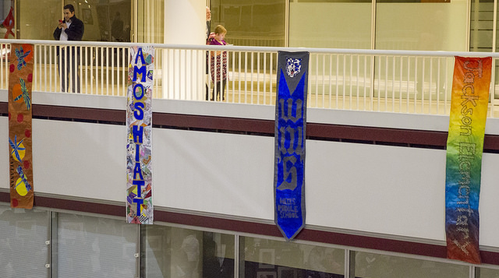
- Project Requirements
1. Each school must complete the banner and hang it with the show pieces for the District Show.
2. Hanging materials will be provided.
3. Banners must be completed by students and interpret the theme of "Think. Learn. Grow."
4. Keep a record of each student involved in the creation of the banner.
5. Any material or technique may be used in the creation of the banner.
6. Banners will be hung vertically.
- Tips for Completing the School Banner
  - Student Management: Involving as many students as possible in the creation of your banner can require thoughtful organization. Some ideas include dividing up the space for individual work, making the banner a lesson extension or early finisher option, or making it the task of an identified group of students.
  - Materials: The banners are made of canvas broadcloth. One side is coated, the other is raw. Either side is suitable for many types of media. Think outside the box! Collage and printmaking could be a great option for teachers on a tight budget. The banners may be altered in any way you see fit. Looking for a great deal on supplies? Don’t forget to check out the latex paint available at the Habitat for Humanity ReStore. Even pencil, pen, or permanent markers can have stunning results. Large amounts of paint are not necessary for a banner of this size. The area is the equivalent of 12 pieces of 12x18 paper (the size most of us stock regularly).
  - Still Stuck? Feel free to reach out to Sarah at sarah.dougherty@dmschools.org or by phone at 515-242-7619.

