ANNUAL DISTRICT ART EXHIBIT
Each year we feature the work of hundreds of students from across the district in our annual art exhibit. This year the show will run from February 18th to March 1st, with an opening reception for artists, families, teachers, and the community on the evening of the 18th. This is the only Des Moines Public Schools event that features students from every single building in our district. The following pages outline requirements and important dates to remember when preparing for our cornerstone event.
Exhibit Details
Exhibit | Thursday, February 18th – Tuesday, March 1st  Displays are open from 5:30 AM to 8:30 PM daily
Reception | Thursday, February 18th  5:30 PM to 7:30 PM
Venue | Des Moines Capital Square Mall Lobby (main floor)  400 Locust Street, downtown
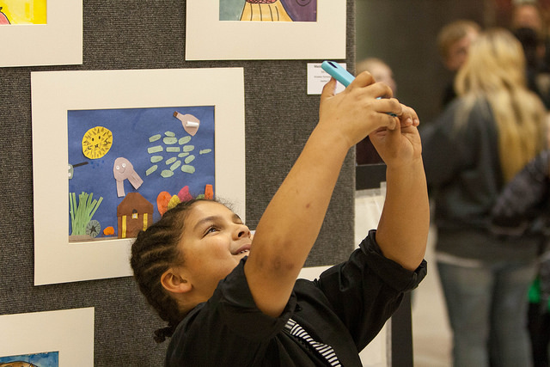
Teacher Timeline
- August-November
  - Work on banners, collect student art for consideration
- December/January
  - Select final pieces for display
  - Receive matt board, invitations, and certificates from PLC meetings
- February/March
  - 3rd -- Submit artist names via Google links
  - 10th – Names must be verified by this date
  - 17th – Hang work at Capital Square between 10 AM and 4 PM
  - 18th – Opening reception from 5:30-7:30 PM
  - March 2nd – Strike show between 5:30 AM and 8:30 PM

Teacher Preparations and Details
2D Work Selection | Each TEACHER will have one 38”x70” display panel on which to hang art. A minimum of four pieces is required from each school. Please use good judgment when determining how many pieces to display in this space. Artwork should not be touching adjacent pieces. Please account for the matt board and your school name when calculating space.  Velcro dots will be provided to attach to the back of your art pieces for hanging. Please mark the back side of your student’s artwork with their name and school as well as your name.  Note: artworks should be fresh, not having been displayed in public prior  Works larger than the display panels may be included, connect with Sarah. Teachers bringing framed art or stretched canvases should plan to bring their own easel. No tape is allowed on the walls of the venue.
Banners | Each school will be provided with a 2’x9’ sign cloth banner on which students should create an artwork representative of your school. They will be hung from the second floor balcony at Capitol Square. More information about banners can be found on our curriculum website under the show tab.
3D Work Selection | Each teacher may choose to display 3D work in addition to the 2D displays. Please connect with Sarah for large or unusual display needs. Work should be clearly labeled with student name and school. Name tags will be provided for this work.
Display and Matts | Matt board will be provided to you at the December/January PLC. Nametags for display will be available at the Feb. 10th set up. Matt may be either black or white.
Name Tags | Name tag information must be submitted via the following links:  For individual student work: http://goo.gl/forms/g6zCYkCfTr  For collaborative work: http://goo.gl/forms/GQ8SnKwiK3  For banners: http://goo.gl/forms/fNHvE1xP10  All names MUST be submitted by Wednesday, February 3rd. Names will be sent out for spelling verification, then sent to the printer no later than Friday, February 10th.
Invitations and Certificates | Invitations will be given to teachers at the December/January district PLC meetings. Digital copies will be emailed to teachers to be forwarded. English and Spanish versions will be available. Please connect with your building translators for other languages.  Participation certificates will be provided at the December/January district PLC to be given to student artists.
Installation | Teachers will hang their artwork at Capital Square any time on Wednesday, February 17th between 10:00 AM and 4:00 PM. Velcro dots, name tags, and zip ties will be available at the venue. All other hanging supplies should be brought by teachers. Your panel will have your school name already on it. Sarah will be there throughout the day to assist as needed.
Show Strike | Teachers (or someone designated by the teacher) are responsible for removing their own artwork and banners between 5:30 AM and 8:30 PM on Wednesday, March 2nd. Please do not take work down before this date. Bring scissors to cut your banner zip ties!!

