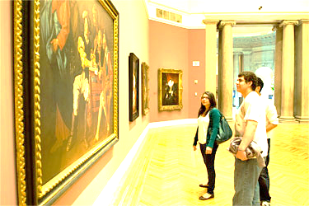
Art History Curriculum Guide
Introduction to Art History (ART 105/106)
Intermediate Art History (Art 231/232)
Advanced Placement Art History (ART 503/504)
2019-2020

Visual Arts Curriculum, Instruction, and Assessment
2100 Fleur Drive | Des Moines, Iowa 50312 | P: 515-242-7619
visualarts.dmschools.org

Superintendent
Thomas Ahart, Ed.D
Executive Director of Secondary Teaching & Learning
Noelle Tichy
Director of Secondary Teaching & Learning
Sarah Dougherty
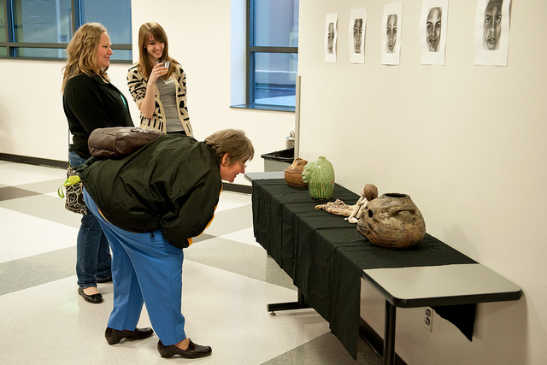
Visual Arts Curriculum Coordinator
Benjamin Heinen
Secondary Curriculum Lead Team Editors – High School
Amy Palmer, North High School
Heather Worthington, Lincoln High School
Becky Johnson, Central Academy

Foreword
Curriculum in this document is based on the National Core Arts Standards published in the spring of 2014. It has been developed by visual art educators and curriculum specialists in the Des Moines Public Schools. The objectives in this curriculum guide are the minimum requirements in the visual arts that set rigorous, relevant, clear, and measurable learning targets and expectations for what teachers should teach and students should learn. Schools and educators are continuously encouraged to go beyond these targets to better serve the needs of all students in the visual arts.

Definition of the Visual Arts
Visual arts include the traditional fine arts such as drawing, painting, printmaking, photography, and sculpture; media arts including film, graphic communications, animation, and emerging technologies; architectural, environmental, and industrial arts such as urban, interior, product, and landscape design; folk arts; and works of art such as ceramics, fibers, jewelry, works in wood, paper, and other materials. –National Art Education Association
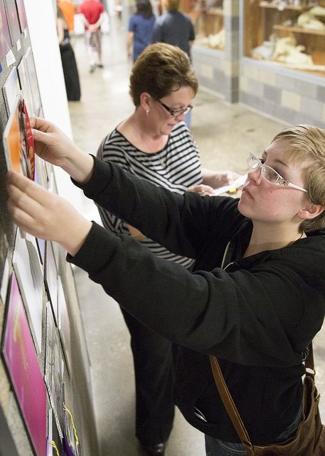
Table of Contents
How to use this document…………………………………………………………………………..5
DMPS Philosophy Learning Objectives……………………………………………………….…..6-7
Document Structures………………………………………………………………………………..8
Intro to Art History Topics……………………………………………………………….………....9-10
Intermediate Art History Topics…………………………………………………………………...11
AP Art History Topics……………...……………………………….……………………………....12
Common Vocabulary………………………………………………………………………………..13
Elements of Art…………………………………………………………………………………...…14
Principles of Design……………………………………………………………………………...…..15
Four-Step Critical Analysis Process……………………………………………………………..…....16

How to use this document:
This curriculum guide is not…
- A lock-step instructional guide detailing exactly when and how you teach.
- Meant to restrict your creativity as a teacher.
- A ceiling of what your students can learn, nor a set of unattainable goals.
Instead, the curriculum guide is meant to be a common vision for student learning and a set of standards by which to measure and report student progress and provide meaningful feedback.
The curriculum guide outlines which learning goals are most essential for student learning; it is our district’s guaranteed and viable curriculum. The expectation is that every student in our district, regardless of school or classroom, will know and understand these learning goals. As the classroom teacher, you should use the curriculum guide to help you to decide how to scaffold up to the learning goals, and extend your students’ learning beyond them.
The curriculum guide is a planning tool; assessed clusters and topics are provided, but as the instructional leader of your classroom, you determine the scope and sequence in which you will introduce the prioritized learning goals. You are encouraged to create your own sub-units of study within each cluster using the topics as a starting point. Within this document you will find a foundational structure for planning instruction in the visual arts which can be supplemented with unlimited materials from any number of sources, including but not limited to district texts and prints.
Please consider this guide a living and dynamic document, subject to change and a part of a continuous feedback loop.

Des Moines Public Schools Educational Philosophy

Vision
Becoming the model for urban education in the United States.

Mission Statement
The Des Moines Public Schools Exist So That Graduates Possess the Knowledge, Skills and Abilities to Be Successful at the Next Stage of Their Lives.

Student Expectations
Students demonstrate proficiency and understanding of a rigorous core curriculum:
- They demonstrate proficiency in reading, writing, speaking and listening
- They demonstrate proficiency in mathematics, including algebra and geometry
- They demonstrate financial and economic literacy
- They demonstrate an understanding of the value of fine and performing arts in society
- They demonstrate proficiency in technological and information literacy
- They demonstrate proficiency in science, including life, earth and physical science

Students possess the knowledge and skills to be self-directed and autonomous:
- They demonstrate critical thinking and problem solving skills
- They exercise sound reasoning in making complex choices
- They exhibit creative, innovative and entrepreneurial thinking
- They understand the attributes of physical and mental well-being

Students have world awareness:
- They learn from and work with individuals representing diverse cultures and religions in a spirit of mutual respect in school, work and community
- They understand the rights and obligations of citizenship at local, state, national, and global levels
- They are actively engaged in community life
- They will be exposed to languages and cultures of the world

Des Moines Public Schools K-12 Student Learning Objectives in the Visual Arts
  - Students can communicate at a foundational level in the visual arts. This includes knowledge and skills in the use of basic vocabularies, materials, tools, techniques, and intellectual methods of the discipline.
  - Students can communicate proficiently in at least one art form, including the ability to define and solve artistic problems with insight, reason, and technical proficiency.
  - Students can develop foundational evaluations and analyses of works of art from structural, historical, and cultural perspectives.
  - Students can develop an informed acquaintance with exemplary works of art from a variety of cultures and historical periods, and a basic understanding of historical development in the arts disciplines, across the arts as a whole, and within cultures.
Effective Components of an Educational Studio Program
  - Demonstrations of artistic techniques and uses of media
  - Opportunities for practice, experimentation, and refinement based on effective feedback
  - Support for divergent thinking and multiple learning outcomes
  - A rich and robust variety of visual references
  - A variety of critique and response formats
  - Introductions to and expectations for use of appropriate art vocabulary
  - Connections among artists, careers, and art in everyday life and communities
  - An organizational system for storage and disbursement of materials and tools
  - Clear and maintained expectations for art room safety, cleaning, and classroom procedures
  - Integrations and connections with other content areas
  - Displays of various student works within the school and the community
- Overarching Learning Objective: Students differentiate the components of form, function, content, and or context of a work of art.

Document Structures
Learning goals for all curricular areas are organized by overarching concepts called topics. Within those topics live a learning goal. All learning goals for the visual arts are guided by the 2014 National Visual Arts Standards and assessed on the provided reporting scales.
Learning goals for Art History courses are guided by the College Board AP Art History standards and objectives.

Evidence of student learning is assessed on a four-point scale, common throughout the district. Scales are designed to measure each learning topic. The generalized scale, with student-friendly language included, is below.
SCALE SCORE | ACADEMIC DESCRIPTOR | STUDENT-FRIENDLY DESCRIPTOR
4 | Exceeding Standard | I have demonstrated deep understanding  that goes beyond the learning goal
3 | Meeting Standard | I have met the learning goal
2 | Developing Toward Standard | I have the foundational skills and knowledge  for the learning goal and I am almost there
1 | Insufficient Progress | The evidence I have submitted shows I have a  long way to go to reach the learning goal
0/M | No evidence of student understanding in submitted work OR  Missing – student has not submitted evidence | I have not submitted evidence of learning for the learning goal
*For more information on district assessment and grading practices, please refer to the Grading Practices website http://grading.dmschools.org/teacher-resources.html

Introduction to Art History, Semester 1 (Art 105/106)
Learning Topic | 1 | 2 | 3 | 4
 | Insufficient Progress | Developing Toward Standard | Meeting Standard | Exceeding Standard
Creating | Student’s performance reflects insufficient progress towards foundational skills and knowledge. | Students demonstrate they have the ability to:  - Use Elements and Principles of Design  - Identify and Describe Elements and Principles of Design in Original Artworks and the Artworks of Others | Students demonstrate they have the ability to:  - Apply relevant criteria from traditional and contemporary cultural contents to examine, reflect on, and plan revisions for works of art and design in progress. | In addition to score 3.0 performance, students demonstrate in-depth inferences and applications that go beyond the learning target.
Connecting | Student’s performance reflects insufficient progress towards foundational skills and knowledge. | Students demonstrate they have the ability to:  - Use Elements and Principles of Design  - Identify and Describe Elements and Principles of Design in Original Artworks and the Artworks of Others | Students demonstrate they have the ability to:  - Create works of art that reflect community and cultural traditions. | In addition to score 3.0 performance, students demonstrate in-depth inferences and applications that go beyond the learning target.
Responding | Student’s performance reflects insufficient progress towards foundational skills and knowledge. | Students demonstrate they have the ability to:  - Use Elements and Principles of Design  - Identify and Describe Elements and Principles of Design in Original Artworks and the Artworks of Others | Students demonstrate they have the ability to:  - Analyze multiple ways that images influence specific audiences. | In addition to score 3.0 performance, students demonstrate in-depth inferences and applications that go beyond the learning target.

Intermediate Art History (Art 231-232)
Learning Topic | 1 | 2 | 3 | 4
 | Insufficient Progress | Developing Toward Standard | Meeting Standard | Exceeding Standard
Creating | Student’s performance reflects insufficient progress towards foundational skills and knowledge. | Students demonstrate the have developed the ability to:  - Develop criteria to guide making a work of art or design to meet an identified goal | Students demonstrate they have the ability to:  - Choose from a range of materials and methods of traditional and contemporary artistic practices to plan works of art and design. | In addition to score 3.0 performance, students demonstrate in-depth inferences and applications that go beyond the learning target.
Connecting | Student’s performance reflects insufficient progress towards foundational skills and knowledge. | Students demonstrate the have developed the ability to:  - Distinguish different ways art is used to represent, establish, reinforce, and reflect group identity. | Students demonstrate they have the ability to:  - Synthesize knowledge of social, cultural, historical, and personal life with art-making approaches to create meaningful works of art or design. | In addition to score 3.0 performance, students demonstrate in-depth inferences and applications that go beyond the learning target.
Responding | Student’s performance reflects insufficient progress towards foundational skills and knowledge. | Students demonstrate the have developed the ability to:  - Analyze how one’s understanding of the world is affected by experiencing visual imagery. | Students demonstrate they have the ability to:  - Recognize and describe personal aesthetic and empathetic responses to the natural world and constructed environments. | In addition to score 3.0 performance, students demonstrate in-depth inferences and applications that go beyond the learning target.

AP Art History (Art 503-504)
Learning Topic | 1 | 2 | 3 | 4
 | Insufficient Progress | Developing Toward Standard | Meeting Standard | Exceeding Standard
Creating | Student’s performance reflects insufficient progress towards foundational skills and knowledge. | Students demonstrate the have developed the ability to:  - Reflect on whether personal artwork conveys the intended meaning and revise accordingly. | Students demonstrate they have the ability to:  - Apply relevant criteria from traditional and contemporary cultural contents to examine, reflect on, and plan revisions for works of art and design in progress. | In addition to score 3.0 performance, students demonstrate in-depth inferences and applications that go beyond the learning target.
Connecting | Student’s performance reflects insufficient progress towards foundational skills and knowledge. | Students demonstrate the have developed the ability to:  - Compare uses of art in a variety of societal, cultural, and historical contexts and make connections to uses of art in contemporary and local contexts. | Students demonstrate they have the ability to:  - Synthesize knowledge of social, cultural, historical, and personal life with art-making approaches to create meaningful works of art or design. | In addition to score 3.0 performance, students demonstrate in-depth inferences and applications that go beyond the learning target.
Responding | Student’s performance reflects insufficient progress towards foundational skills and knowledge. | Students demonstrate the have developed the ability to:  - Analyze how responses to art develop over time based on knowledge of and experience with art and life. | Students demonstrate they have the ability to:  Evaluate the effectiveness of an image or images to influence ideas, feelings, and behaviors of specific audiences. | In addition to score 3.0 performance, students demonstrate in-depth inferences and applications that go beyond the learning target.

Intro Art History: Creating

4 | In addition to score 3.0 performance, the student demonstrates in-depth inferences and applications that go beyond the learning goal.
3 | - Apply relevant criteria from traditional and contemporary cultural contents to examine, reflect on, and plan revisions for works of art and design in progress.
2 | Students demonstrate they have the ability to:  - Reflect on whether personal artwork conveys the intended meaning and revise accordingly.
1 | Student’s performance reflects insufficient progress towards foundational skills and knowledge.
Cognitive Complexity of Target/s
- Analysis

Success Criteria
- I can analyze and apply relevant criteria from traditional and contemporary cultural contents in my plans for my art and design in progress.
- What role does persistence play in revising, refining, and developing work?

National Core Arts Connections:
- Generate and conceptualize artistic ideas and work
- Enduring Understanding: Artists and designers shape artistic investigations, following or breaking with traditions in pursuit of creative art-making goals
- Essential Question/s: Why do artists follow or break from established traditions?

Academic Vocabulary
Including, but not limited to…
Traditional, contemporary, form, function, content, context, traditional, contemporary, revise, refine

Intro Art History: Connecting

4 | In addition to score 3.0 performance, the student demonstrates in-depth inferences and applications that go beyond the learning goal.
3 | - Create works of art that reflect community and cultural traditions.
2 | Students demonstrate they have the ability to:  - Document how art reflects changing times, traditions, resources, and cultural uses.
1 | Student’s performance reflects insufficient progress towards foundational skills and knowledge.
National Core Arts Connections:
- Synthesize and relate knowledge and personal experiences to make art
- Enduring Understanding: Through art-making, people make meaning by investigating and developing awareness of perceptions, knowledge, and experiences.
- Essential Question/s: How does engaging in
Creating art enrich people’s lives?

Cognitive Complexity of Target/s
- Analysis

Academic Vocabulary
Including, but not limited to…
Traditional, contemporary, form, function, content, context, media, community, cultural

Success Criteria
- I can create art that connects with my culture and community
- I can describe how art reflects our time, traditions, and resources.

Intro Art History: Responding

4 | In addition to score 3.0 performance, the student demonstrates in-depth inferences and applications that go beyond the learning goal.
3 | - Analyze multiple ways that images influence specific audiences.
2 | Students demonstrate they have the ability to:  - Compare one’s own interpretation of a work of art with the interpretation of others.
1 | Student’s performance reflects insufficient progress towards foundational skills and knowledge.
National Core Arts Connections:
- Perceive and analyze artwork
- Enduring Understanding: Visual imagery influences understanding of and responses in the world.
- Essential Question/s: How does learning about art impact how we see the world?

Success Criteria
- I can discuss a number of ways in which images can influence audiences.
- I can discuss my own interpretation of a work of art with others.
Cognitive Complexity of Target/s
- Analysis

Academic Vocabulary
Including, but not limited to…
Form, function, content, context, traditional, contemporary, propaganda, persuasion, reaction, empathy, respect, fact, opinion, interpretation

Intermediate Art History: Creating

4 | In addition to score 3.0 performance, the student demonstrates in-depth inferences and applications that go beyond the learning goal. Artistic practices
3 | - Choose from a range of materials and methods of traditional and contemporary artistic practices to plan works of art and design.
2 | Students demonstrate they have the ability to:  - Develop criteria to guide making a work of art or design to meet an identified goal.
1 | Student’s performance reflects insufficient progress towards foundational skills and knowledge.
Cognitive Complexity of Target/s
- Analysis

Academic Vocabulary
Including, but not limited to…
Traditional, contemporary, form, function, content, context, thumbnail sketch, refine, criteria.

Success Criteria
- I can plan a work of art, choosing from a range of materials.
- I can develop criteria to guide my art making process.

National Core Arts Connections:
- Organize and develop artistic ideas and work
- Artists and Designers experiment with forms, structures, materials, concepts, media, and art-making approaches
- Essential Question/s: How do artists work?
How do artists and designers determine whether a particular direction in their work is effective?

Intermediate Art History: Connecting

4 | In addition to score 3.0 performance, the student demonstrates in-depth inferences and applications that go beyond the learning goal.
3 | - Synthesize knowledge of social, cultural, historical, and personal life with art-making approaches to create meaningful works of art or design.
2 | Students demonstrate they have the ability to:  - Compare uses of art in a variety of societal, cultural, and historical contexts and make connections to uses of art in contemporary and local contexts.
1 | Student’s performance reflects insufficient progress towards foundational skills and knowledge.
Success Criteria
- I can compare, create, and/or understand works of art by synthesizing my knowledge of social, cultural, historical, and personal life experiences
- I can also relate this knowledge to contemporary and local contexts.
Academic Vocabulary
Including, but not limited to…
Form, function, content, context, traditional, contemporary, group identity, observation aesthetics, societal, cultural.

National Core Arts Connections:
- Synthesize and relate knowledge and personal experiences in art making
- Enduring Understanding: Through art-making, people make meaning by investigating and developing awareness of perception, knowledge, and experiences.
- Essential Question/s: How does engaging in
the creation of art enrich people’s lives?
How is art used to impact the view of a society?
Cognitive Complexity of Target/s
- Analysis

Intermediate Art History: Responding

4 | In addition to score 3.0 performance, the student demonstrates in-depth inferences and applications that go beyond the learning goal.
3 | - Analyze multiple ways that images influence specific audiences.
2 | Students demonstrate they have the ability to:  - Compare one’s own interpretation of a work of art with the interpretation of others.
1 | Student’s performance reflects insufficient progress towards foundational skills and knowledge.
National Core Arts Connections:
- Perceive and analyze artwork
- Enduring Understanding: Visual imagery influences understanding of and responses in the world.
- Essential Question/s: How does learning about art impact how we see the world?

Academic Vocabulary
Including, but not limited to…
Form, function, content, context, traditional, contemporary, propaganda, persuasion, reaction, empathy, respect, fact, opinion, interpretation

Success Criteria
- I can discuss a number of ways in which images can influence audiences.
- I can discuss my own interpretation of a work of art with others.

Cognitive Complexity of Target/s
- Analysis

AP Art History: Creating

4 | In addition to score 3.0 performance, the student demonstrates in-depth inferences and applications that go beyond the learning goal.
3 | - Apply relevant criteria from traditional and contemporary cultural contents to examine, reflect on, and plan revisions for works of art and design in progress.
2 | Students demonstrate they have the ability to:  - Reflect on whether personal artwork conveys the intended meaning and revise accordingly.
1 | Student’s performance reflects insufficient progress towards foundational skills and knowledge.
Cognitive Complexity of Target/s
- Analysis

Success Criteria
- I can analyze and apply relevant criteria from traditional and contemporary cultural contents in my plans for my art and design in progress.
- What role does persistence play in revising, refining, and developing work?

National Core Arts Connections:
- Generate and conceptualize artistic ideas and work
- Enduring Understanding: Artists and designers shape artistic investigations, following or breaking with traditions in pursuit of creative art-making goals
- Essential Question/s: Why do artists follow or break from established traditions?

Academic Vocabulary
Including, but not limited to…
Traditional, contemporary, form, function, content, context, traditional, contemporary, revise, refine

AP Art History: Connecting

4 | In addition to score 3.0 performance, the student demonstrates in-depth inferences and applications that go beyond the learning goal.
3 | - Synthesize knowledge of social, cultural, historical, and personal life with art-making approaches to create meaningful works of art or design.
2 | Students demonstrate they have the ability to:  - Compare uses of art in a variety of societal, cultural, and historical contexts and make connections to uses of art in contemporary and local contexts.
1 | Student’s performance reflects insufficient progress towards foundational skills and knowledge.
Success Criteria
- I can compare, create, and/or understand works of art by synthesizing my knowledge of social, cultural, historical, and personal life experiences
- I can also relate this knowledge to contemporary and local contexts.
Academic Vocabulary
Including, but not limited to…
Form, function, content, context, traditional, contemporary, group identity, observation aesthetics, societal, cultural.

National Core Arts Connections:
- Synthesize and relate knowledge and personal experiences in art making
- Enduring Understanding: Through art-making, people make meaning by investigating and developing awareness of perception, knowledge, and experiences.
- Essential Question/s: How does engaging in
the creation of art enrich people’s lives?
How is art used to impact the view of a society?
Cognitive Complexity of Target/s
- Analysis

National Core Arts Connections:
- Perceive and analyze artwork
- Enduring Understanding: Visual imagery influences understanding of and responses in the world.
- Essential Question/s: How do images influence our views of the world?

Success Criteria
- I can evaluate the effectiveness of an image in terms of how it influences ideas, feelings, and the behavior of certain audiences.
AP Art History: Responding

4 | In addition to score 3.0 performance, the student demonstrates in-depth inferences and applications that go beyond the learning goal.
3 | - Evaluate the effectiveness of an image or images to influence ideas, feelings, and behaviors of specific audiences.
2 | Students demonstrate they have the ability to:  - Analyze how responses to art develop over time based on knowledge of and experience with art and life.
1 | Student’s performance reflects insufficient progress towards foundational skills and knowledge.
Cognitive Complexity of Target/s
- Analysis

Academic Vocabulary
Including, but not limited to…
Form, function, content, context, traditional, contemporary, propaganda, persuasion, reaction

Common Vocabulary Terms
Common vocabulary for selected media, styles, art movements, and art expressions reflect the concepts, techniques, and skills for each grade level and course of study. Students will use these terms in oral, written, and visual communications. Teachers are encouraged to provide additional visual arts vocabulary to the identified lists.
Recommended Terms
Analysis  Context  Concept  Convention  Patronage  Commission  Chronological  Geographical  Form  Function  Material  Medium/Media | Thematic  Aesthetic  Tradition  Iconography  Perceptual  Intellectual  Religious  Ideology  Political  Philosophical  Social Class  Gender | Power/Authority  Morality  Normality  Architecture  Sculpture  Painting  Cross-Cultural  Status  Migration  Subculture  Mainstream Culture  Milieu | Controversy  Transformation  Intention  Contemporary  Traditional  Divination  Diagnosis  Holistic  Custodianship  Protocol  Efficacy

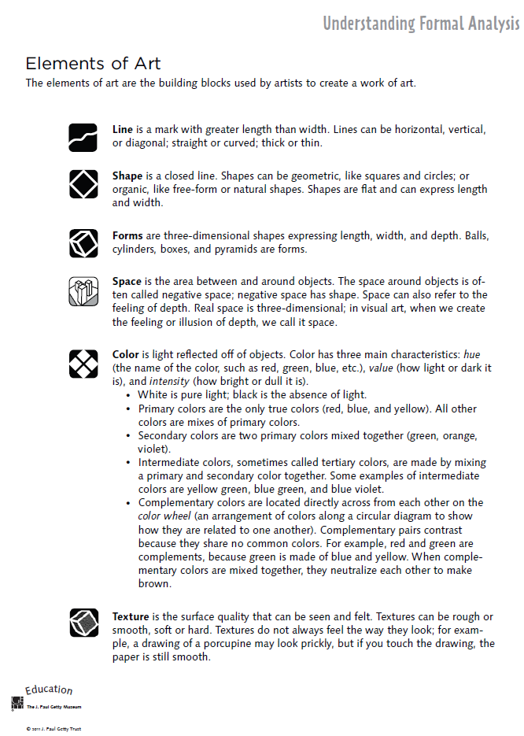

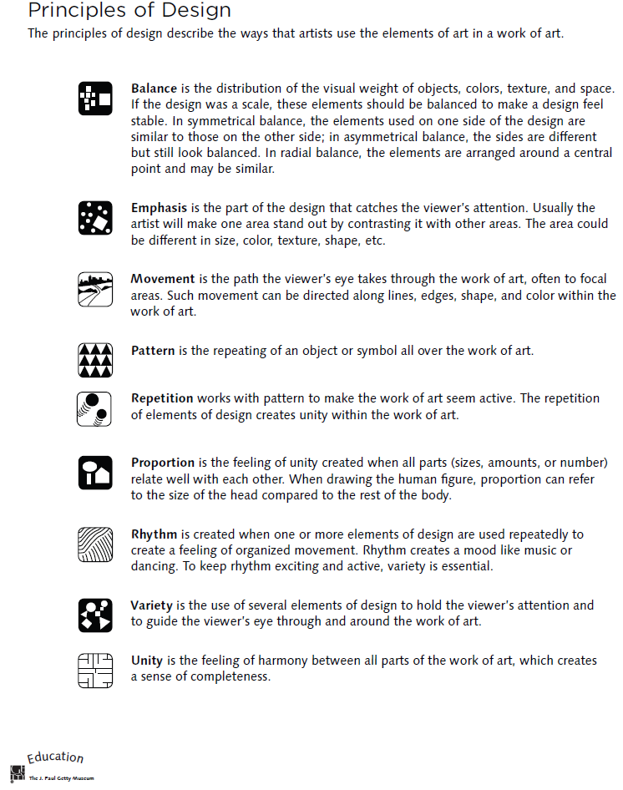
Four-Step Critical Analysis Process
- Step 1: Describe – What do you see?
  - Credit line information such as title, artist, date created, size, medium, location, genre.
  - What do you see in the art work? Use objective observations and identification skills. All descriptions must be observable facts.
  - EXAMPLE: “Starry Night, Vincent Van Gogh, 1832…I see a large cypress tree in the foreground. I can tell it is a cypress by the shape. The majority of the picture is taken up by a night sky. There are many stars in the sky. Etc….”
- Step 2: Analyze—How is the work organized?
  - Focus on how the Elements of Art and Principles of Design have been used in the artwork. You are still collecting clues, not guessing! How do the Principles organize the Elements? Use specific evidence from the art. This will help you discover how the artist might have created moods, messages, or ideas.
  - EXAMPLE: “The night sky is dark blue, and it is filled with vibrant yellow stars. The pattern of the stars moves the viewer’s eye back and forth throughout the painting. The repetition of the yellow into the village lights help give the picture unity. Etc….”
- Step 3: Interpret – “What is the artist saying?”
  - Using the information from the description and analysis, explain what the artist might be trying to communicate. What is the mood or the meaning of the artwork? Make some guesses and provide some evidence for your thinking using the Elements and Principles. Your interpretation might be different from someone else’s.
  - Answer the question, “I think________________, because I see __________________.”
  - EXAMPLE: “I think the artist is trying to show a connection between a sleepy peaceful mood and the quiet little town, because the artists uses the some colors and kinds of lines in the sky and the village. I see the colors and the soft, swirling lines in the sky, and it makes me think the artist was trying to show that even a dark sky can have lots to see. Etc….”
- Step 4: Judge – “Is this a successful piece of art?”
  - Now you can finally express your own personal opinion about the piece of art. Your opinion, however, is still based on what you’ve discovered through description, analysis, and interpretation, all backed up with visual evidence and the language of art. This is a carefully thought out decision in which you decided if the art was successful or not successful, not necessarily a like or dislike.
  - Answer this questions, “I think this work is (not) successful because _____________________.”
  - EXAMPLE: “I think this work is successful because it the colors and lines are organized in an interesting, swirly way that grabs my attention. The work is almost like a lullaby because the yellow stars twinkle in the sky like peaceful little notes over the sleepy town. Etc…

