Visual arts include the traditional fine arts such as drawing, painting, printmaking, photography, and sculpture; media arts including film, graphic communications, animation, and emerging technologies; architectural, environmental, and industrial arts such as urban, interior, product, and landscape design; folk arts; and works of art such as ceramics, fibers, jewelry, works in wood, paper, and other materials. –National Art Education Association
The Des Moines Public Schools offer a comprehensive, hands-on approach to learning and mastering the skills in visual arts as a key part of our Educational Philosophy, Vision, Mission, and Student Expectations.

Elementary Visual Arts Curriculum Guide
Grades K-5
2017-2018

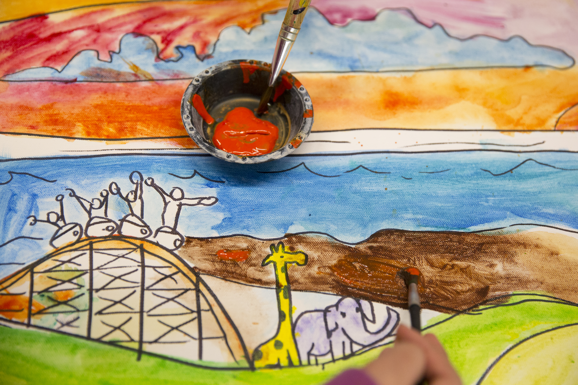
Superintendent
Thomas Ahart, Ed.D

Executive Director of Teaching & Learning
Noelle Tichy

Elementary Director of Teaching & Learning
Kelly Schofield

Secondary Director of Teaching & Learning
Sarah Dougherty

Visual Arts Curriculum Coordinator
Benjamin Heinen

Elementary Curriculum Lead Team Editors
Lisa Hesse, Findley Elementary
Kara Dare, Cowles Montessori School
Jennifer Warner-Blankenship, Park Avenue Elementary
Augwenda Papich, Garton and Brubaker Elementary
Kathleen Davenport, Madison Elementary
Mindi McCoy, Perkins Elementary
Emily Bash, Hubbell Elementary
Katherine Boes Chojnacki, Hillis Elementary
Lisa Rasmussen, Phillips Elementary
Lindsie Manzer, Willard Elementary

Secondary Curriculum Lead Team Editors – High School
Amy Palmer, North High School
Heather Worthington, Lincoln High School
Secondary Curriculum Lead Team Editors – Middle School
Jessica Wenck, Weeks Middle School
Kara Dare, Cowles Montessori School
Margo Greenberg, Meredith Middle School

Foreword
Curriculum in this document is based on the National Core Arts Standards published in the spring of 2014. It has been developed by visual art educators and curriculum specialists in the Des Moines Public Schools. The objectives in this curriculum guide are the minimum requirements in the visual arts that set rigorous, relevant, clear, and measurable learning targets and expectations for what teachers should teach and students should learn. Schools and educators are continuously encouraged to go beyond these targets to better serve the needs of all students in the visual arts.

Definition of the Visual Arts
Visual arts include the traditional fine arts such as drawing, painting, printmaking, photography, and sculpture; media arts including film, graphic communications, animation, and emerging technologies; architectural, environmental, and industrial arts such as urban, interior, product, and landscape design; folk arts; and works of art such as ceramics, fibers, jewelry, works in wood, paper, and other materials. –National Art Education Association

Table of Contents
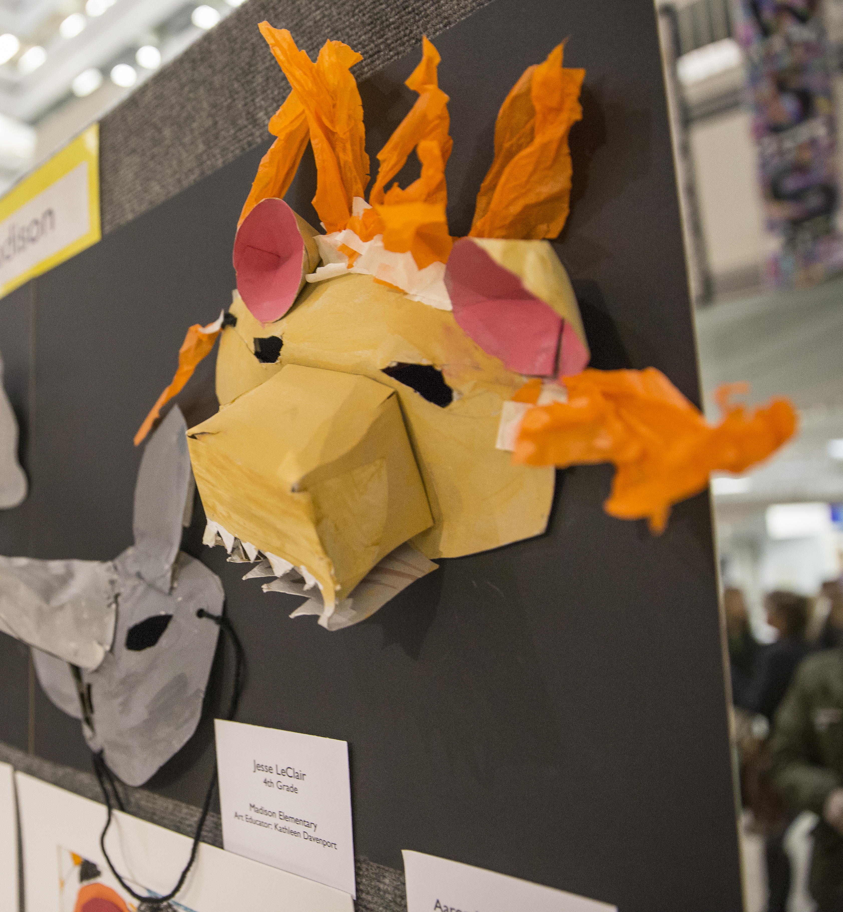
How to use this document……………………………………………..5

DMPS Educational Philosophy………………………………………..6

DMPS Art Learning Objectives………………………………………..7

Document Structures…………………………………………………...8

Learning Topics Description…………………………………………..8

Standards Referenced Grading Basics………………………………....9

K-5 Learning Goals……………………………………………………..10-12

Grade Level Scales……………………………………………………...13-28

Common Vocabulary……………………………………………….…..29

Elements of Art………………………………………………………....30

Principles of Design………………………………………………..…..30

Four-Step Critical Analysis Process…………………………………...31

How to use this document:
This curriculum guide is not…
- A lock-step instructional guide detailing exactly when and how you teach.
- Meant to restrict your creativity as a teacher.
- A ceiling of what your students can learn, nor a set of unattainable goals.
Instead, the curriculum guide is meant to be a common vision for student learning and a set of standards by which to measure and report student progress and provide meaningful feedback.
The curriculum guide outlines which learning goals are most essential for student learning; it is our district’s guaranteed and viable curriculum. The expectation is that every student in our district, regardless of school or classroom, will know and understand these learning goals. As the classroom teacher, you should use the curriculum guide to help you to decide how to scaffold up to the learning goals, and extend your students’ learning beyond them.
The curriculum guide is a planning tool; assessed clusters and topics are provided, but as the instructional leader of your classroom, you determine the scope and sequence in which you will introduce the prioritized learning goals. You are encouraged to create your own sub-units of study within each cluster using the topics as a starting point. Within this document you will find a foundational structure for planning instruction in the visual arts which can be supplemented with unlimited materials from any number of sources, including but not limited to district texts and prints.
Please consider this guide a living and dynamic document, subject to change and a part of a continuous feedback loop.
Des Moines Public Schools Educational Philosophy

Vision
Becoming the model for urban education in the United States.

Mission Statement
The Des Moines Public Schools Exist So That Graduates Possess the Knowledge, Skills and Abilities to Be Successful at the Next Stage of Their Lives.

Student Expectations
Students demonstrate proficiency and understanding of a rigorous core curriculum:
- They demonstrate proficiency in reading, writing, speaking and listening
- They demonstrate proficiency in mathematics, including algebra and geometry
- They demonstrate financial and economic literacy
- They demonstrate an understanding of the value of fine and performing arts in society
- They demonstrate proficiency in technological and information literacy
- They demonstrate proficiency in science, including life, earth and physical science

Students possess the knowledge and skills to be self-directed and autonomous:
- They demonstrate critical thinking and problem solving skills
- They exercise sound reasoning in making complex choices
- They exhibit creative, innovative and entrepreneurial thinking
- They understand the attributes of physical and mental well-being

Students have world awareness:
- They learn from and work with individuals representing diverse cultures and religions in a spirit of mutual respect in school, work and community
- They understand the rights and obligations of citizenship at local, state, national, and global levels
- They are actively engaged in community life
- They will be exposed to languages and cultures of the world
- Des Moines Public Schools K-12 Student Learning Objectives in the Visual Arts
  - Students can communicate at a foundational level in the visual arts. This includes knowledge and skills in the use of basic vocabularies, materials, tools, techniques, and intellectual methods of the discipline.
  - Students can communicate proficiently in at least one art form, including the ability to define and solve artistic problems with insight, reason, and technical proficiency.
  - Students can develop foundational evaluations and analyses of works of art from structural, historical, and cultural perspectives.
  - Students can develop an informed acquaintance with exemplary works of art from a variety of cultures and historical periods, and a basic understanding of historical development in the arts disciplines, across the arts as a whole, and within cultures.
- Effective Components of an Educational Studio Program
  - Demonstrations of artistic techniques and uses of media
  - Opportunities for practice, experimentation, and refinement based on effective feedback
  - Support for divergent thinking and multiple learning outcomes
  - A rich and robust variety of visual references
  - A variety of critique and response formats
  - Introductions to and expectations for use of appropriate art vocabulary
  - Connections among artists, careers, and art in everyday life and communities
  - An organizational system for storage and disbursement of materials and tools
  - Clear and maintained expectations for art room safety, cleaning, and classroom procedures
  - Integrations and connections with other content areas
  - Displays of various student works within the school and the community

Document Structures
Learning goals for all curricular areas are organized by overarching concepts called topics. Within those topics live a learning goal. All learning goals for the visual arts are guided by the 2014 National Visual Arts Standards and assessed on the provided reporting scales. The outline below serves to define the various elements of the curriculum structure.
Learning Topic – The Overarching Concept
  - Definition of the topic.
  - National Standards alignments – those most closely related to the overarching concept.
SCALE SCORE | ACADEMIC DESCRIPTOR | STUDENT-FRIENDLY DESCRIPTOR
4 | Exceeding Standard | I have demonstrated deep understanding  that goes beyond the learning goal
3 | Meeting Standard | I have met the learning goal
2 | Developing Toward Standard | I have the foundational skills and knowledge  for the learning goal and I am almost there
1 | Insufficient Progress | The evidence I have submitted shows I have a  long way to go to reach the learning goal
0/M | No evidence of student understanding in submitted work OR  Missing – student has not submitted evidence | I have not submitted evidence of learning for the learning goal
*For more information on district assessment and grading practices, please refer to the Grading Practices website http://grading.dmschools.org/teacher-resources.html

Standards-Referenced Grading Basics
Evidence shows the student can... | Topic Score
Demonstrate all learning targets from Level 3 and Level 4 | 4.0
Demonstrate all learning targets from Level 3 with partial success at Level 4 | 3.5
Demonstrate all learning targets from Level 3 | 3.0
Demonstrate some of the Level 3 learning targets | 2.5
Demonstrate all learning targets from Level 2 but none of the learning targets from Level 3 | 2.0
Demonstrate some of the Level 2 learning targets and none of the Level 3 learning targets | 1.5
Demonstrate none of the learning targets from Level 2 or Level 3 | 1.0
Produce no evidence appropriate to the learning targets at any level | 0
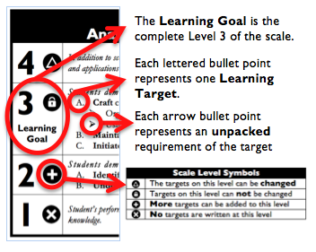
The teacher designs instructional activities that grow and measure a student’s skills in the elements identified on our topic scales. Each scale features many such skills and knowledges, also called learning targets. These are noted on the scale below with letters (A, B, C) and occur at Levels 2 and 3 of the scale. In the grade book, a specific learning activity could be marked as being 3A, meaning that the task measured the A item at Level 3.
When identifying a Topic Score, the teacher looks at all evidence for the topic. The table to the right shows which Topic Score is entered based on what the Body of Evidence shows.
Only scores of 4, 3.5, 3, 2.5, 2, 1.5, 1, and 0 can be entered as Topic Scores.
Guiding Practices of Standards-Referenced Grading
1. A consistent 4-point grading scale will be used.
2. Student achievement and behavior will be reported separately.
3. Scores will be based on a body of evidence.
4. Achievement will be organized by learning topic and converted to a grade at semester’s end.
5. Students will have multiple opportunities to demonstrate proficiency.
6. Accommodations and modifications will be provided for exceptional learners.

Multiple Opportunities
It’s not about going back to do a retake, or back to redo something; it’s about going forward, continually scaffolding student learning through multiple opportunities, and noting that improved learning. Our curriculum builds on itself. “Multiple opportunities” are about taking an assessment and connecting it to past topics. It’s about allowing students to demonstrate their learning multiple times in units subsequent to their current unit, or when learning is scaffolded into future units.

Grade Level Year-Long Learning Goals
K-1

Topic | Kindergarten | First Grade
Creating & Connecting | - Generate and conceptualize artistic ideas and work  - Engage in exploration and imaginative play with materials (VA:Cr1.1.Ka)  - Engage collaboratively in creative art-making in response to an artistic problem (VA:Cr1.2.Ka)  - Synthesize and relate knowledge and personal experiences to make art  - Create art that tells a story about a life experience (VA:Cn10.1.Ka) | - Generate and conceptualize artistic ideas and work  - Engage collaboratively in exploration and imaginative play with materials (VA:Cr1.1.1a)  - Relate artistic ideas and works with societal, cultural, and historical context to deepen understanding  - Understand that people from different places and times have made art for a variety of reasons. (VA Cn1.1.1a)
Presenting & Responding | - Select, analyze, and interpret artistic work for presentation  - Select art objects for personal portfolio and display, explaining why they are chosen. (VA: Pr4.1.Ka)  - Apply criteria to evaluate artistic work  - Explain reasons for selecting a preferred artwork.  (VA: Re9.1.Ka) | - Select, analyze and interpret artistic work for presentation  - Explain why some objects, artifacts and artwork are valued over others. (VA:Pr4.1.1a)  - Perceive and analyze artistic work  - Compare images that represent the same subject. (VA:Re.7.2.1a)
Grade Level Year-Long Learning Goals
2-3
Topic | Second Grade | Third Grade
Creating & Connecting | - Organize and develop artistic ideas and work  - Experiment with various materials and tools to explore personal interests in a work of art or design. (VA:Cr2.1.2a)  - Synthesize and relate knowledge and personal experiences to make art  - Create works of art about events in home, school, or community life. (VA: Cn10.1.3a) | - Refine and complete artistic work.  - Elaborate visual information by adding details in an artwork to enhance emerging meaning. (VA:Cr3.1.3a)  - Relate artistic ideas and works with societal, cultural and historical context to deepen understanding.  - Compare and contrast how artwork changes based on the time and place in which it was created.* (VA:Cn11.1.2a & 3a – adapted)
Presenting & Responding | - Select, analyze, and interpret artistic work for presentation  - Categorize artwork based on a theme or concept for an exhibit. (VA:Pr4.1.2a)  - Interpret intent and meaning in artistic work  - Interpret art by identifying the mood suggested by a work of art and describing relevant subject matter and characteristics. (Adapted VA:Re8.1.1a) | - Convey meaning through the presentation of artistic work  - Identify and explain how and where different cultures record and illustrate stories and history of life through art. (VA:Pr6.1.3a)  - Record and illustrate stories and history of life through art. (VA:Pr6.1.3a)  - Perceive and analyze artistic work  - Determine messages communicated by an image. (VA:Re.7.2.3a)

Grade Level Year-Long Learning Goals
4-5
Topic | Fourth Grade | Fifth Grade
Creating & Connecting | - Generate and Conceptualize artistic ideas and work  - Collaboratively set goals and create artwork that is meaningful and has purpose to the makers.  (VA: Cr 1.2.4a)  - Brainstorm multiple approaches to a creative art or design problem and utilize the best approach in an original work of art. (Adapted VA: Cr 1.1.4a)  - Synthesize and relate knowledge and personal experiences to make art  - Create works of art that reflect community, cultural traditions (VA; Cn 10.1.4a) | - Refine and complete artistic work  - Reflect on whether personal artwork conveys the intended meaning and revise accordingly.  (VA: Cr.3.1.6a)  - Relate artistic ideas and works with societal, cultural, and historical contexts to deepen understanding  - Identify how art is used to inform or change beliefs, values, or behaviors of an individual or society. (VA:Cn11.1.5a)
Presenting & Responding | - Convey meaning through presentation of artistic work  - Compare and contrast purposes of art museums, art galleries, and/or other venues, as well as the types of personal experiences they provide. (Adapted VA:PR6.1.4a)  - Apply criteria to evaluate artistic work  - Apply one set of criteria to evaluate more than one work of art. (VA:Re9.1.4a) | - Develop and refine artistic techniques and work for presentation  - Develop a logical argument for preparing and presenting artwork. (ADAPTED VA:Pr5.1.5a)  - Perceive and analyze artistic work  - Compare one’s own interpretation of a work of art with the interpretation of others. (VA:Re.7.1.5a)
Kindergarten: Creating & Connecting

4 | In addition to scoring a 3.0, the student demonstrates in-depth inferences and applications that go beyond the learning goal.
3 | Students demonstrate they have the ability to:  - Generate and conceptualize artistic ideas and work.  - Engage in exploration and imaginative play with materials (VA:Cr1.1.Ka)  - Engage collaboratively in creative art-making in response to an artistic problem (VA:Cr1.2.Ka)  - Synthesize and relate knowledge and personal experiences to make art.  - Create art that tells a story about a life experience (VA:Cn10.1.Ka)
2 | - Use Elements and Principles of Design  - Line  - Shape  - Pattern  - Color (Primary & Secondary)
1 | Student’s performance reflects beginning-to-learn foundational skills and knowledge.
Cognitive Complexity of Learning Goals:

- Comprehension/Analysis
- Knowledge Utilization

Enduring Understandings:
- Creativity and innovative thinking are essential life skills that can be developed.
- Synthesize and relate knowledge and personal experiences to make art.

Essential Questions:
- What conditions, attitudes, and behaviors support creativity?
- Through art-making, people make meaning by investigating and developing awareness of perceptions, knowledge, and experiences.
Kindergarten : Presenting & Responding

4 | In addition to scoring a 3.0, the student demonstrates in-depth inferences and applications that go beyond the learning goal.
3 | - Select, analyze, and interpret artistic work for presentation.  - Select art objects for personal portfolio and display, explaining why they are chosen. (VA: Pr4.1.Ka)  - Apply criteria to evaluate artistic work.  - Explain reasons for selecting a preferred artwork. (VA: Re9.1.Ka)
2 | - Identify and Describe Elements and Principles of Design.  - Line  - Shape  - Pattern  - Color (Primary & Secondary)
1 | Student’s performance reflects beginning-to-learn foundational skills and knowledge.
Cognitive Complexity of Learning Goals:

- Analysis
- Knowledge Utilization

Enduring Understandings:

- Artists and other presenters consider various techniques, methods, venues, and criteria when analyzing, selecting, and curating objects, artifacts, and artworks for preservation and presentation.

- People evaluate art based on various criteria.

Essential Questions:

- How are artworks cared for and by whom? What criteria, methods, and processes are used to select work for preservation or presentation? Why do people value objects, artifacts, artworks, and select them for presentation.

- How does one determine criteria to evaluate a work of art? How and why might criteria vary? How is a personal preference different from an evaluation?

First Grade: Creating & Connecting

4 | In addition to scoring a 3.0, the student demonstrates in-depth inferences and applications that go beyond the learning goal.
3 | - Generate and conceptualize artistic ideas and work.  - Engage collaboratively in exploration and imaginative play with materials (VA:Cr1.1.1a)  - Relate artistic ideas and works with societal, cultural, and historical context to deepen understanding.  - Understand that people from different places and times have made art for a variety of reasons.  (VA Cn1.1.1a)
2 | - Use Elements and Principles of Design.  Texture  Repetition  Variety  Color: Complementary
1 | Student’s performance reflects beginning-to-learn foundational skills and knowledge.
Cognitive Complexity of Learning Goals:
- Analysis
- Analysis

Enduring Understandings:

- Creativity and innovative thinking are essential life skills that can be developed.

- Artists and designers balance experimentation and safety freedom and responsibility while developing and creating artworks

Essential Question(s):

- What conditions, attitudes, and behaviors support creativity and innovative thinking?
- What factors prevent or encourage people to take creative risks?
- How does collaboration expand the creative process?
First Grade: Presenting & Responding

4 | In addition to scoring a 3.0, the student demonstrates in-depth inferences and applications that go beyond the learning goal.
3 | - Select, analyze and interpret artistic work for presentation.  - Explain why some objects, artifacts and artwork are valued over others. (VA:Pr4.1.1a)  - Perceive and analyze artistic work.  - Compare images that represent the same subject. (VA:Re.7.2.1a)
2 | - Identify and Describe Elements and Principles of Design  - Texture  - Repetition  - Variety  - Color Theory (complementary colors)
1 | Student’s performance reflects beginning-to-learn foundational skills and knowledge.
Cognitive Complexity of Learning Goals:
- Analysis
- Analysis

Enduring Understandings:

- Artists and other presenters consider various techniques, methods, venues and criteria when analyzing, selecting and curating objects, artifacts and artworks for preservation and presentation.

- Visual imagery influences understanding of and responses to the world.

Essential Questions:

- Why do people value objects, artifacts, and artworks, and select them for presentation?

- What is an image? Where and how do we encounter images in our world? How do images influence our views of the world?
Second Grade: Creating & Connecting

4 | In addition to scoring a 3.0, the student demonstrates in-depth inferences and applications that go beyond the learning goal.
- Organize and develop artistic ideas and work
  - Experiment with various materials and tools to explore personal interests in a work of art or design. (VA:Cr2.1.2a)

- Synthesize and relate knowledge and personal experiences to make art.
  - Create works of art about events in home, school, or community life. (VA: Cn10.1.3a)

2 | - Use Elements and Principles of Design  - Form  - Movement  - Rhythm  - Color Theory (warm and cool)
1 | Student’s performance reflects beginning-to-learn foundational skills and knowledge.
Cognitive Complexity of Learning Goals:
- Analysis
- Analysis

Enduring Understandings:
- Artists and designers experiment with forms, structures, materials, concepts, media, and art-making approaches.
- Through art-making people make meaning by investigating and developing awareness of perceptions, knowledge, and experiences.

Essential Questions:
- How do artist work? How do artists and designers determine whether a particular direction in their work is effective? How do artists and designers learn from trial and error?

- How does engaging in creating art enrich people’s lives? How does art-making attune people to their surroundings? How do people contribute to awareness and understanding of their lives and the lives of their communities through art-making?
Second Grade: Presenting & Responding

4 | In addition to scoring a 3.0, the student demonstrates in-depth inferences and applications that go beyond the learning goal.
3 | - Select, analyze, and interpret artistic work for presentation.  - Categorize artwork based on a theme or concept for an exhibit. (VA:Pr4.1.2a)  - Interpret intent and meaning in artistic work.  - Interpret art by identifying the mood suggested by a work of art and describing relevant subject matter and characteristics. (Adapted VA:Re8.1.1a)
2 | - Use Elements and Principles of Design  - Form  - Movement  - Rhythm  - Color (Cool & Warm)
1 | Student’s performance reflects beginning-to-learn foundational skills and knowledge.
Cognitive Complexity of Learning Goals:
- Analysis
- Comprehension

Enduring Understandings:

- Artists and other presenters consider various techniques, methods, venues, and criteria when analyzing, selecting, and curating objects, artifacts, and artworks for preservation and presentation.

- Visual imagery influences understanding of and responses to the world.

Essential Questions:

- How are artworks cared for and by whom? What criteria, methods, processes are used to select work for preservation or presentation? Why do people value objects, artifacts, and artworks, and select them for presentation?

- What is the value of engaging in the process of art criticism? How can the viewer “read” a work of art as text? How does knowing and using art vocabularies help us understand and interpret works of art?
Third Grade: Creating & Connecting

4 | In addition to scoring a 3.0, the student demonstrates in-depth inferences and applications that go beyond the learning goal.
3 | - Refine and complete artistic work.  - Elaborate visual information by adding details in an artwork to enhance emerging meaning. (VA:Cr3.1.3a)  - Relate artistic ideas and works with societal, cultural and historical context to deepen understanding.  - Compare and contrast how artwork changes based on the time and place in which it was created.* (VA:Cn11.1.2a & 3a – adapted)
2 | - Use Elements and Principles of Design  - Value  - Emphasis  - Balance  - Color (Shade & Tint)
1 | Student’s performance reflects beginning-to-learn foundational skills and knowledge.
Cognitive Complexity of Learning Goals:
- Analysis
- Analysis

Enduring Understandings:
- Artist and designers develop excellence through practice and constructive critique, reflecting on, revising, and refining work over time.

- People develop ideas and understandings of society, culture and history through their interactions with and analysis of art.

Essential Questions:
- What role does persistence play in revising, refining, and developing work? How do artists grow and become accomplished in art forms? How does collaboratively reflecting on a work help us experience it more completely?

- How does art help us understand the lives of people of different times, places and cultures? How is art used to impact the views of a society? How does art preserve aspects of life?
Third Grade: Presenting & Responding

4 | In addition to scoring a 3.0, the student demonstrates in-depth inferences and applications that go beyond the learning goal.
3 | - Convey meaning through the presentation of artistic work.  - Identify and explain how and where different cultures record and illustrate stories and history of life through art. (VA:Pr6.1.3a)  - Record and illustrate stories and history of life through art. (VA:Pr6.1.3a)  - Perceive and analyze artistic work.  - Determine messages communicated by an image. (VA:Re.7.2.3a)
2 | - Identify and Describe Elements and Principles of Design  - Value  - Emphasis  - Balance  - Color Theory (shade and tint)
1 | Student’s performance reflects beginning-to-learn foundational skills and knowledge.
Enduring Understandings:

- Objects, artifacts, and artworks collected, preserved or presented either by artists, museums, or other venues communicate meaning and a record of social, cultural, and political experiences resulting in the cultivating of appreciation and understanding.

- Visual imagery influences understanding of and responses to the world.

Essential Questions:

- How does the presenting and sharing of objects, artifacts, and artworks influence and shape ideas, beliefs, and experiences?

- How does learning about art impact how we perceive the world?
Cognitive Complexity of Learning Goals:
- Comprehension
- Analysis

Fourth Grade: Creating & Connecting

4 | In addition to scoring a 3.0, the student demonstrates in-depth inferences and applications that go beyond the learning goal.
3 | - Generate and Conceptualize artistic ideas and work.  - Collaboratively set goals and create artwork that is meaningful and has purpose to the makers. (VA: Cr 1.2.4a)  - Brainstorm multiple approaches to a creative art or design problem and utilize the best approach in an original work of art.  (Adapted VA: Cr 1.1.4a)  - Synthesize and relate knowledge and personal experiences to make art.  - Create works of art that reflect community, cultural traditions (VA; Cn 10.1.4a)
2 | - Use Elements and Principles of Design  - Space  - Unity  - Proportion  - Color : Tertiary
1 | Student’s performance reflects beginning-to-learn foundational skills and knowledge.

Enduring Understandings:

- Through art-making, people make meaning by investigating and developing awareness of perceptions, knowledge, and experiences

- Artists and designers shape artistic investigations following or breaking with traditions in pursuit of creative art making goals

Essential Questions:

- How does engaging in creating art enrich people’s lives? How does making art attune to their surroundings?

- How do people contribute to awareness and understanding of their lives and the lives of their communities through art-making?

Cognitive Complexity of Learning Goals:
- Knowledge Utilization
- Analysis

Fourth Grade: Presenting & Responding

4 | In addition to scoring a 3.0, the student demonstrates in-depth inferences and applications that go beyond the learning goal.
3 | - Convey meaning through presentation of artistic work.  - Compare and contrast purposes of art museums, art galleries, and/or other venues, as well as the types of personal experiences they provide.  (Adapted VA:PR6.1.4a)  - Apply criteria to evaluate artistic work.  - Apply one set of criteria to evaluate more than one work of art. (VA:Re9.1.4a)
2 | - Identify and Describe Elements and Principles of Design  - Space  - Unity  - Proportion  - Color Theory (Tertiary Colors)
1 | Student’s performance reflects beginning-to-learn foundational skills and knowledge.
Cognitive Complexity of Learning Goals:
- Analysis
- Knowledge Utilization

Enduring Understandings:
- Objects, artifacts, and artworks, collected, preserved or presented either by artists, museums, or other venues, communicate meaning and a record social, cultural, and political experiences resulting in the cultivating of appreciation and understanding.
- People evaluate art based on various criteria.

Essential Questions:
- What is an art museum? How does the presenting and sharing of objects, artifacts, and artworks influence and shape ideas, beliefs, and experiences? How do objects, artifacts, and artworks collected, preserved, or presented, cultivate appreciation and understanding?
- How does one determine criteria to evaluate a work of art? How and why might criteria vary? How is personal preference different than an evaluation?
Fifth Grade: Creating & Connecting

4 | In addition to scoring a 3.0, the student demonstrates in-depth inferences and applications that go beyond the learning goal.
3 | - Refine and complete artistic work.  - Reflect on whether personal artwork conveys the intended meaning and revise accordingly  (VA: Cr.3.1.6a)  - Relate artistic ideas and works with societal, cultural, and historical contexts to deepen understanding.  - Identify how art is used to inform or change beliefs, values, or behaviors of an individual or society. (VA:Cn11.1.5a)
2 | - Use Elements and Principles of Design  - Using given criteria, choose elements and principles to create and original artwork, and justify the choices.  - Create artist statements using art vocabulary to describe personal choices in art-making.
1 | Student’s performance reflects beginning-to-learn foundational skills and knowledge.
Cognitive Complexity of Learning Goals:
- Analysis
- Analysis

Enduring Understandings:

- Artist and designers develop excellence through practice and constructive critique, reflecting on, revising, and refining work over time.
- Through art-making, people make meaning by investigating and developing awareness of perceptions, knowledge, and experiences.

Essential Questions:

- What role does persistence play in revising, refining, and developing work? How do artists grow and become accomplished in art forms? How does collaboratively reflecting on a work help us experience it more completely?
- How does engaging in creating art enrich people’s lives? How does making art attune people to their surroundings? How do people contribute to awareness and understanding of their lives and the lives of their communities through art-making?
Fifth Grade: Presenting & Responding

4 | In addition to scoring a 3.0, the student demonstrates in-depth inferences and applications that go beyond the learning goal.
3 | - Develop and refine artistic techniques and work for presentation.  - Develop a logical argument for preparing and presenting artwork. (ADAPTED VA:Pr5.1.5a)  - Perceive and analyze artistic work.  - Compare one’s own interpretation of a work of art with the interpretation of others. (VA:Re.7.1.5a)
2 | - Use Elements and Principles of Design  - Identify and describe elements and principles design in original artworks and the artwork of others.  - Create artist statements using art vocabulary to describe personal choices in art-making.
1 | Student’s performance reflects beginning-to-learn foundational skills and knowledge.
Cognitive Complexity of Learning Goals:
- Analysis
- Analysis

Enduring Understandings:

- Artists, curators and others consider a variety of factors and methods including evolving technologies when preparing and refining artwork for display and or when deciding if and how to preserve and protect it.
- Individual aesthetic and empathetic awareness developed through engagement with art can lead to understanding and appreciation of self, others, the natural world, and constructed environments.

Essential Questions:
- What methods and processes are considered when preparing artwork for presentation and preservation? How does refining artwork affect it’s meaning to the viewer? What criteria are considered when selecting work for presentation, a portfolio, or a collection?

- How do life experiences influence the way you relate to art? How does learning about art impact how we perceive the world? What can we learn from our responses to art?

Common Vocabulary Terms
Common vocabulary for selected media, styles, art movements, and art expressions reflect the concepts, techniques, and skills for each grade level and course of study. Students will use these terms in oral, written, and visual communications. Teachers are encouraged to provide additional visual arts vocabulary to the identified lists.
Highly Recommended Terms |  |  | Recommended Terms
- Line  - Shape  - Forms  - Space  - Color  - Texture  - Value  - Primary  - Secondary  - Complementary  - Shade  - Tint | - Balance  - Emphasis  - Movement  - Pattern  - Repetition  - Proportion  - Rhythm  - Variety  - Unity | - Composition  - Perspective  - Craftsmanship  - Portfolio  - Technique  - Context  - Media  - Critique | - Horizontal  - Vertical  - Diagonal  - Geometric  - Organic  - Length  - Width  - Depth  - Negative Space  - Positive Space | - Hue  - Intensity  - Surface  - Scale  - Symmetry  - Asymmetry | - Contrast  - Focal Point  - Symbol  - Mood  - Harmony

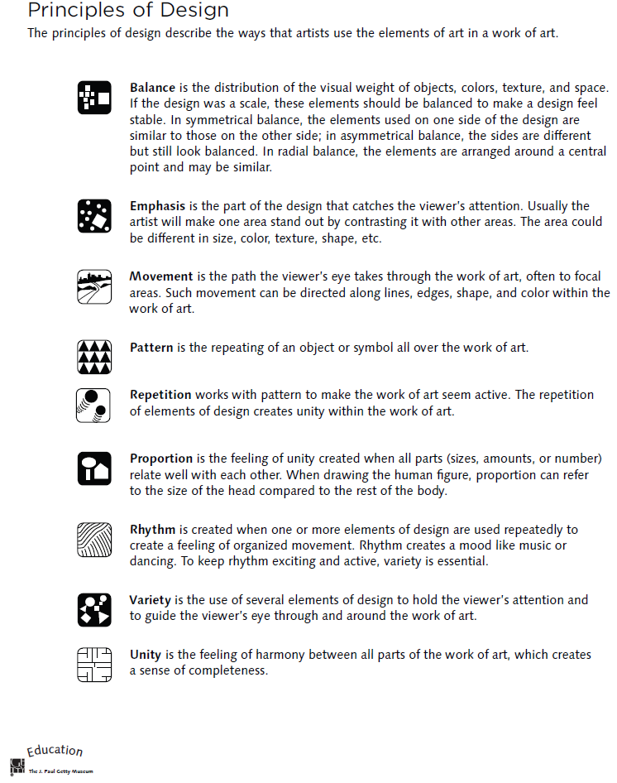
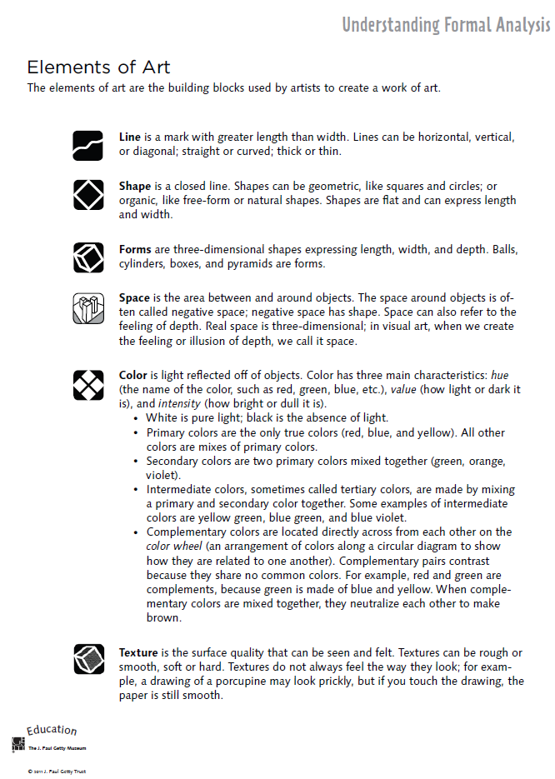
Four-Step Critical Analysis Process
- Step 1: Describe – What do you see?
  - Credit line information such as title, artist, date created, size, medium, location, genre.
  - What do you see in the art work? Use objective observations and identification skills. All descriptions must be observable facts.
  - EXAMPLE: “Starry Night, Vincent Van Gogh, 1832…I see a large cypress tree in the foreground. I can tell it is a cypress by the shape. The majority of the picture is taken up by a night sky. There are many stars in the sky. Etc….”
- Step 2: Analyze—How is the work organized?
  - Focus on how the Elements of Art and Principles of Design have been used in the artwork. You are still collecting clues, not guessing! How do the Principles organize the Elements? Use specific evidence from the art. This will help you discover how the artist might have created moods, messages, or ideas.
  - EXAMPLE: “The night sky is dark blue, and it is filled with vibrant yellow stars. The pattern of the stars moves the viewer’s eye back and forth throughout the painting. The repetition of the yellow into the village lights help give the picture unity. Etc….”
- Step 3: Interpret – “What is the artist saying?”
  - Using the information from the description and analysis, explain what the artist might be trying to communicate. What is the mood or the meaning of the artwork? Make some guesses and provide some evidence for your thinking using the Elements and Principles. Your interpretation might be different from someone else’s.
  - Answer the question, “I think________________, because I see __________________.”
  - EXAMPLE: “I think the artist is trying to show a connection between a sleepy peaceful mood and the quiet little town, because the artists uses the some colors and kinds of lines in the sky and the village. I see the colors and the soft, swirling lines in the sky, and it makes me think the artist was trying to show that even a dark sky can have lots to see. Etc….”
- Step 4: Judge – “Is this a successful piece of art?”
  - Now you can finally express your own personal opinion about the piece of art. Your opinion, however, is still based on what you’ve discovered through description, analysis, and interpretation, all backed up with visual evidence and the language of art. This is a carefully thought out decision in which you decided if the art was successful or not successful, not necessarily a like or dislike.
  - Answer this questions, “I think this work is (not) successful because _____________________.”
  - EXAMPLE: “I think this work is successful because it the colors and lines are organized in an interesting, swirly way that grabs my attention. The work is almost like a lullaby because the yellow stars twinkle in the sky like peaceful little notes over the sleepy town. Etc….”

