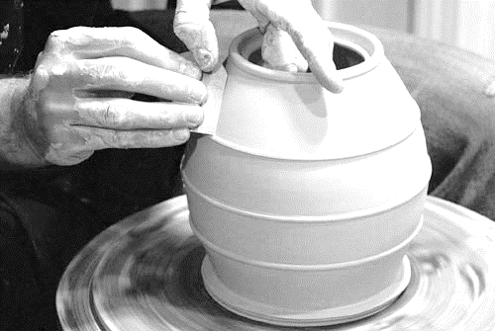
Throwing
(ART 351A/352A, 353A/354A, 451A/452A)
Curriculum Guide
© September, 2016

Visual Arts Curriculum, Instruction, and Assessment
2100 Fleur Drive | Des Moines, Iowa 50312 | P: 515-242-7619
visualarts.dmschools.org

Superintendent
Thomas Ahart, Ed.D
Executive Director of Secondary Teaching & Learning
Noelle Tichy
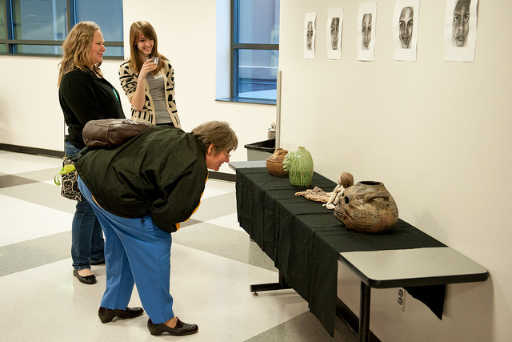
Visual Arts Curriculum Coordinator
Sarah Dougherty
3D Design Curriculum Editors
Dara Green – Central Academy

Foreword
Curriculum in this document is based on the National Core Arts Standards published in the spring of 2014. It has been developed by visual art educators and curriculum specialists in the Des Moines Public Schools. The objectives in this curriculum guide are the minimum requirements in the visual arts that set rigorous, relevant, clear, and measurable learning targets and expectations for what teachers should teach and students should learn. Schools and educators are continuously encouraged to go beyond these targets to better serve the needs of all students in the visual arts.

Definition of the Visual Arts
Visual arts include the traditional fine arts such as drawing, painting, printmaking, photography, and sculpture; media arts including film, graphic communications, animation, and emerging technologies; architectural, environmental, and industrial arts such as urban, interior, product, and landscape design; folk arts; and works of art such as ceramics, fibers, jewelry, works in wood, paper, and other materials. –National Art Education Association
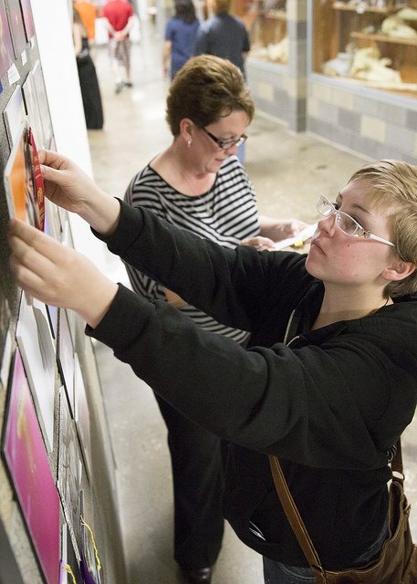
Table of Contents
How to use this document…………………………………………………………………………..4
DMPS Art Learning Objectives……………………………………………………………………..5
Document Structures………………………………………………………………………………..6
Assessment Rubrics………………………………………………………………………………....7
Elements of Art…………………………………………………………………………………...…18
Principles of Design……………………………………………………………………………...…..19
Four-Step Critical Analysis Process……………………………………………………………..…....20

How to use this document:
This curriculum guide is not…
- A lock-step instructional guide detailing exactly when and how you teach.
- Meant to restrict your creativity as a teacher.
- A ceiling of what your students can learn, nor a set of unattainable goals.
Instead, the curriculum guide is meant to be a common vision for student learning and a set of standards by which to measure and report student progress and provide meaningful feedback.
The curriculum guide outlines which learning goals are most essential for student learning; it is our district’s guaranteed and viable curriculum. The expectation is that every student in our district, regardless of school or classroom, will know and understand these learning goals. As the classroom teacher, you should use the curriculum guide to help you to decide how to scaffold up to the learning goals, and extend your students’ learning beyond them.
The curriculum guide is a planning tool; assessed clusters and topics are provided, but as the instructional leader of your classroom, you determine the scope and sequence in which you will introduce the prioritized learning goals. You are encouraged to create your own sub-units of study within each cluster using the topics as a starting point. Within this document you will find a foundational structure for planning instruction in the visual arts which can be supplemented with unlimited materials from any number of sources, including but not limited to district texts and prints.
Please consider this guide a living and dynamic document, subject to change and a part of a continuous feedback loop. As part of this logic model, common task banks and district-wide common formative assessments are being generated during the 2014-2015 and 2015-2016 school years.

Des Moines Public Schools Educational Philosophy

Vision
Becoming the model for urban education in the United States.

Mission Statement
The Des Moines Public Schools Exist So That Graduates Possess the Knowledge, Skills and Abilities to Be Successful at the Next Stage of Their Lives.

Student Expectations
Students demonstrate proficiency and understanding of a rigorous core curriculum:
- They demonstrate proficiency in reading, writing, speaking and listening
- They demonstrate proficiency in mathematics, including algebra and geometry
- They demonstrate financial and economic literacy
- They demonstrate an understanding of the value of fine and performing arts in society
- They demonstrate proficiency in technological and information literacy
- They demonstrate proficiency in science, including life, earth and physical science

Students possess the knowledge and skills to be self-directed and autonomous:
- They demonstrate critical thinking and problem solving skills
- They exercise sound reasoning in making complex choices
- They exhibit creative, innovative and entrepreneurial thinking
- They understand the attributes of physical and mental well-being

Students have world awareness:
- They learn from and work with individuals representing diverse cultures and religions in a spirit of mutual respect in school, work and community
- They understand the rights and obligations of citizenship at local, state, national, and global levels
- They are actively engaged in community life
- They will be exposed to languages and cultures of the world

Des Moines Public Schools K-12 Student Learning Objectives in the Visual Arts
  - Students can communicate at a foundational level in the visual arts. This includes knowledge and skills in the use of basic vocabularies, materials, tools, techniques, and intellectual methods of the discipline.
  - Students can communicate proficiently in at least one art form, including the ability to define and solve artistic problems with insight, reason, and technical proficiency.
  - Students can develop foundational evaluations and analyses of works of art from structural, historical, and cultural perspectives.
  - Students can develop an informed acquaintance with exemplary works of art from a variety of cultures and historical periods, and a basic understanding of historical development in the arts disciplines, across the arts as a whole, and within cultures.
- Effective Components of an Educational Studio Program
  - Demonstrations of artistic techniques and uses of media
  - Opportunities for practice, experimentation, and refinement based on effective feedback
  - Support for divergent thinking and multiple learning outcomes
  - A rich and robust variety of visual references
  - A variety of critique and response formats
  - Introductions to and expectations for use of appropriate art vocabulary
  - Connections among artists, careers, and art in everyday life and communities
  - An organizational system for storage and disbursement of materials and tools
  - Clear and maintained expectations for art room safety, cleaning, and classroom procedures
  - Integrations and connections with other content areas
  - Displays of various student works within the school and the community
- Learning Topics for Three Dimensional Design
Beginning Throwing (ART 351A/352A) | Intermediate Throwing (ART 353A/354A) | Advanced Throwing (ART 451A/452A)
- Studio Skills: Tools  - Throwing  - Surface Treatments  - Critical Analysis | - Studio Skills  - Throwing  - Surface Treatments  - Critical Analysis | - Studio Skills  - Throwing  - Surface Treatments  - Critical Analysis
Document Structures
Learning goals for all curricular areas are organized by overarching concepts called topics. Within those topics live a learning goal. All learning goals for the visual arts are guided by the 2014 National Visual Arts Standards and assessed on the provided reporting scales. The outline below serves to define the various elements of the curriculum structure.
- Learning Topic – The Overarching Concept
  - Definition of the topic.
  - National Standards alignments – those most closely related to the overarching concept.
    - Anchor Standard: Anchor standards define the expectations for students entering college and careers, and provide the foundation for the K-12 visual arts standards.
    - Enduring Understanding: Statements summarizing important ideas and core processes that are central to visual arts and have lasting value beyond the classroom. They synthesize what students should understand—not just know or do—as a result of studying visual arts.
    - Essential Questions: Organizing questions to set the focus for lessons or units. They are the initiators of creative and critical thinking.
Evidence of student learning is assessed on a four-point scale, common throughout the district. Scales are designed to measure each learning topic. The generalized scale, with student-friendly language included, is below.
SCALE SCORE | ACADEMIC DESCRIPTOR | STUDENT-FRIENDLY DESCRIPTOR
4 | Exceeding Standard | I have demonstrated deep understanding  that goes beyond the learning goal
3 | Meeting Standard | I have met the learning goal
2 | Developing Toward Standard | I have the foundational skills and knowledge  for the learning goal and I am almost there
1 | Insufficient Progress | The evidence I have submitted shows I have a  long way to go to reach the learning goal
0/M | No evidence of student understanding in submitted work OR  Missing – student has not submitted evidence | I have not submitted evidence of learning for the learning goal
*For more information on district assessment and grading practices, please refer to the Grading Practices website http://grading.dmschools.org/teacher-resources.html

351A/352A, 353A/354A, 451A/452A Learning Topic – Studio Skills
  - Artistic Media and Processes are defined as the means of expression (tools, materials, and techniques) used to produce a work of art.
  - New National Standards alignments
    - Anchor Standard: Organize and develop artistic ideas and work.
    - Enduring Understandings
      - Artists and designers experiment with forms, structures, materials, concepts, media, and art-making approaches.
      - Artists and designers balance experimentation and safety, freedom and responsibility, while developing and creating art
    - Essential Questions
      - How do artists work?
      - How do artists care for and maintain materials, tools, and equipment?
      - What responsibilities come with the freedom to create?

Assessment Scales – Topic: Studio Skills
Course | 1 | 2 | 3: LEARNING GOAL | 4
351A  Beginning Throwing S1 | Student’s performance reflects insufficient progress towards foundational skills and knowledge. | Students will recognize or recall specific vocabulary such as:  - Leather hard, bone dry, bisque, glazeware  Students demonstrate they have developed the ability to:  - Identify and describe the intended uses of tools. | Students demonstrate they have the ability to:  - Create and use an effective tool. | In addition to score 3.0 performance, students demonstrate in-depth inferences and applications that go beyond the learning target.
352A  Beginning Throwing S2 | Student’s performance reflects insufficient progress towards foundational skills and knowledge. | Students will recognize or recall specific vocabulary such as:  - Leather hard, bone dry, bisque, glazeware  Students demonstrate they have developed the ability to:  - Identify and describe the intended uses of tools. | Students demonstrate they have the ability to:  - Use studio tools correctly and effectively | In addition to score 3.0 performance, students demonstrate in-depth inferences and applications that go beyond the learning target.
353A/354A  Intermediate Throwing S1/S2 | Student’s performance reflects insufficient progress towards foundational skills and knowledge. | Students will recognize or recall specific vocabulary such as:  - Leather hard, bone dry, bisque, glazeware  Students demonstrate they have developed the ability to:  - Identify and explain the functions and applications of studio equipment. | Students demonstrate they have the ability to:  - Use and maintain studio equipment safely and effectively. | In addition to score 3.0 performance, students demonstrate in-depth inferences and applications that go beyond the learning target.
451A/452A  Advanced Throwing S1/S2 | Student’s performance reflects insufficient progress towards foundational skills and knowledge. | Students demonstrate they have the ability to:  - Use and maintain studio equipment safely and effectively. | Students demonstrate they have the ability to:  - Use and maintain studio equipment safely and effectively, and independently. | In addition to score 3.0 performance, students demonstrate in-depth inferences and applications that go beyond the learning target.

Assessment Scales – Topic: Throwing
Course | 1 | 2 | 3: LEARNING GOAL | 4
351A  Beginning Throwing S1 | Student’s performance reflects insufficient progress towards foundational skills and knowledge. | Students demonstrate the have developed they ability to:  A. Identify, describe, and attempt foundational wheel and hand-building skills. | Students demonstrate they have the ability to:  - Apply foundational wheel skills:  - Wedging, centering, center hole, pulling the floor and walls, trimming on the wheel, creating an undercut, removing a form from the wheel.  - Apply foundational hand-building skills to create a form with instructional integrity. | In addition to score 3.0 performance, students demonstrate in-depth inferences and applications that go beyond the learning target.
352A  Beginning Throwing S2 | Student’s performance reflects insufficient progress towards foundational skills and knowledge. | Students demonstrate the have developed they ability to:  A. Identify, describe, and attempt foundational wheel skills. | Students demonstrate they have the ability to:  A. Apply foundational wheel skills:  - Bellying, choking, cutting the rim, throwing off the hump, trimming.  B. Create a series of similarly sized and shaped forms. | In addition to score 3.0 performance, students demonstrate in-depth inferences and applications that go beyond the learning target.
353A  Intermediate Throwing S1 | Student’s performance reflects insufficient progress towards foundational skills and knowledge. | Students demonstrate the have developed they ability to:  A. Identify, describe, and attempt intermediate wheel skills. | Students demonstrate they have the ability to:  A. Apply intermediate wheel skills:  - Throwing for production, altering wheel-thrown pieces. | In addition to score 3.0 performance, students demonstrate in-depth inferences and applications that go beyond the learning target.
354A  Intermediate Throwing S2 | Student’s performance reflects insufficient progress towards foundational skills and knowledge. | Students demonstrate the have developed they ability to:  A. Identify, describe, and attempt intermediate wheel skills. | Students demonstrate they have the ability to:  A. Apply intermediate wheel skills:  - Creating large-scale forms, creating nesting forms. | In addition to score 3.0 performance, students demonstrate in-depth inferences and applications that go beyond the learning target.
451A/452A  Advanced Throwing S1/S2 | Student’s performance reflects insufficient progress towards foundational skills and knowledge. | Students demonstrate the have developed they ability to:  - Independently select from a range of techniques to set an artistic goal. | Students demonstrate they have the ability to:  - Independently select from a range of techniques to reach an artistic goal. | In addition to score 3.0 performance, students demonstrate in-depth inferences and applications that go beyond the learning target.

Assessment Scales – Topic: Surface Treatments
Course | 1 | 2 | 3: LEARNING GOAL | 4
351A  Beginning Throwing S1 | Student’s performance reflects insufficient progress towards foundational skills and knowledge. | Students demonstrate the have developed they ability to:  A. Identify, describe, and attempt foundational surface treatment techniques. | Students demonstrate they have the ability to:  - Apply texture to ceramic forms.  - Apply foundational glaze techniques. | In addition to score 3.0 performance, students demonstrate in-depth inferences and applications that go beyond the learning target.
352A  Beginning Throwing S2 | Student’s performance reflects insufficient progress towards foundational skills and knowledge. | Students demonstrate the have developed they ability to:  A. Identify, describe, and attempt foundational surface treatment techniques. | Students demonstrate they have the ability to:  A. Choose and apply surface treatments and basic glaze techniques. | In addition to score 3.0 performance, students demonstrate in-depth inferences and applications that go beyond the learning target.
353A  Intermediate Throwing S1 | Student’s performance reflects insufficient progress towards foundational skills and knowledge. | Students demonstrate the have developed they ability to:  A. Identify, describe, and attempt intermediate surface treatment techniques. | Students demonstrate they have the ability to:  A. Choose and test glaze materials and techniques. | In addition to score 3.0 performance, students demonstrate in-depth inferences and applications that go beyond the learning target.
354A  Intermediate Throwing S2 | Student’s performance reflects insufficient progress towards foundational skills and knowledge. | Students demonstrate the have developed they ability to:  A. Identify, describe, and attempt intermediate surface treatment techniques. | Students demonstrate they have the ability to:  A. Choose and apply materials and techniques to fit the needs of their work. | In addition to score 3.0 performance, students demonstrate in-depth inferences and applications that go beyond the learning target.
451A/452A  Advanced Throwing S1/S2 | Student’s performance reflects insufficient progress towards foundational skills and knowledge. | Students demonstrate the have developed they ability to:  - Independently select from a range of techniques to set an artistic goal. | Students demonstrate they have the ability to:  - Independently select from a range of techniques to reach an artistic goal. | In addition to score 3.0 performance, students demonstrate in-depth inferences and applications that go beyond the learning target.

351A/352A, 353A/354A, 452A/452A Learning Topic – Critical Analysis
  - Evaluating is defined as judging the merits or value of a piece of art based on a set of criteria.
  - New National Standards alignments
    - Anchor Standards
      - Refine and complete artistic work.
      - Interpret intent and meaning in artistic work.
      - Apply criteria to evaluate artistic work.
    - Enduring Understandings
      - Artists and designers develop excellence through practice and constructive critique, reflecting on, revising, and refining work over time.
      - People gain insights into meanings of artworks by engaging in the process of art criticism.
      - People evaluate art based on various criteria.
    - Essential Questions
      - How do artists grow and become accomplished in art forms?
      - How does collaboratively reflecting on work help us experience it more fully and develop it more completely?
      - How does the viewer “read” a work of art?
      - How is personal preference different from an evaluation?

Assessment Scales – Topic: Critical Analysis
Course | 1 | 2 | 3: LEARNING GOAL | 4
351A/352A | Student’s performance reflects insufficient progress towards foundational skills and knowledge. | Students demonstrate they have developed the ability to:  Formulate and communicate an action plan. | Students demonstrate they have the ability to:  - Formulate, communicate, and implement an action plan, making appropriate adjustments. | In addition to score 3.0 performance, students demonstrate in-depth inferences and applications that go beyond the learning target.
353A/354A | Student’s performance reflects insufficient progress towards foundational skills and knowledge. | Students demonstrate they have developed the ability to:  Formulate and communicate an action plan. | Students demonstrate they have the ability to:  - Formulate, communicate, and implement an action plan, making appropriate adjustments.  - Research and present a pottery related topic. | In addition to score 3.0 performance, students demonstrate in-depth inferences and applications that go beyond the learning target.
451A/452A | Student’s performance reflects insufficient progress towards foundational skills and knowledge. | Students demonstrate they have developed the ability to:  Formulate and communicate an action plan. | Students demonstrate they have the ability to:  - Formulate, communicate, and implement an action plan, making appropriate adjustments.  - Analyze, select, and curate artworks for presentation and preservation. | In addition to score 3.0 performance, students demonstrate in-depth inferences and applications that go beyond the learning target.

Beginning Throwing S1 (ART351) Assessment Rubric
Topic | 1 | 2 | 3 | 4
 | Insufficient Progress | Developing Toward Standard | Meeting Standard  Learning GOAL | Exceeding Standard
Studio Skills | Student’s performance reflects insufficient progress towards foundational skills and knowledge. | Students will recognize or recall specific vocabulary such as:  - Leather hard, bone dry, bisque, glazeware  Students demonstrate they have developed the ability to:  Identify and describe the intended uses of tools. | Students demonstrate they have the ability to:  - Create and use an effective tool. | In addition to score 3.0 performance, students demonstrate in-depth inferences and applications that go beyond the learning target.
Throwing | Student’s performance reflects insufficient progress towards foundational skills and knowledge. | Students demonstrate the have developed they ability to:  A. Identify, describe, and attempt foundational wheel and hand-building skills. | Students demonstrate they have the ability to:  - Apply foundational wheel skills:  - Wedging, centering, center hole, pulling the floor and walls, trimming on the wheel, creating an undercut, removing a form from the wheel.  - Apply foundational hand-building skills to create a form with instructional integrity. | In addition to score 3.0 performance, students demonstrate in-depth inferences and applications that go beyond the learning target.
Surface Treatments | Student’s performance reflects insufficient progress towards foundational skills and knowledge. | Students demonstrate the have developed they ability to:  A. Identify, describe, and attempt foundational surface treatment techniques. | Students demonstrate they have the ability to:  - Apply texture to ceramic forms.  Apply foundational glaze techniques. | In addition to score 3.0 performance, students demonstrate in-depth inferences and applications that go beyond the learning target.
Critical Analysis | Student’s performance reflects insufficient progress towards foundational skills and knowledge. | Students demonstrate they have developed the ability to:  - Formulate and communicate an action plan. | Students demonstrate they have the ability to:  - Formulate, communicate, and implement an action plan, making appropriate adjustments. | In addition to score 3.0 performance, students demonstrate in-depth inferences and applications that go beyond the learning target.

Beginning Throwing S2 (ART352A) Assessment Rubric
Topic | 1 | 2 | 3 | 4
 | Insufficient Progress | Developing Toward Standard | Meeting Standard  Learning GOAL | Exceeding Standard
Studio Skills | Student’s performance reflects insufficient progress towards foundational skills and knowledge. | Students will recognize or recall specific vocabulary such as:  - Leather hard, bone dry, bisque, glazeware  Students demonstrate they have developed the ability to:  - Identify and describe the intended uses of tools. | Students demonstrate they have the ability to:  - Use studio tools correctly and effectively | In addition to score 3.0 performance, students demonstrate in-depth inferences and applications that go beyond the learning target.
Throwing | Student’s performance reflects insufficient progress towards foundational skills and knowledge. | Students demonstrate the have developed they ability to:  A. Identify, describe, and attempt foundational wheel skills. | Students demonstrate they have the ability to:  A. Apply foundational wheel skills:  - Bellying, choking, cutting the rim, throwing off the hump, trimming.  B. Create a series of similarly sized and shaped forms. | In addition to score 3.0 performance, students demonstrate in-depth inferences and applications that go beyond the learning target.
Surface Treatments | Student’s performance reflects insufficient progress towards foundational skills and knowledge. | Students demonstrate the have developed they ability to:  A. Identify, describe, and attempt foundational surface treatment techniques. | Students demonstrate they have the ability to:  A. Choose and apply surface treatments and basic glaze techniques. | In addition to score 3.0 performance, students demonstrate in-depth inferences and applications that go beyond the learning target.
Critical Analysis | Student’s performance reflects insufficient progress towards foundational skills and knowledge. | Students demonstrate they have developed the ability to:  - Formulate and communicate an action plan. | Students demonstrate they have the ability to:  - Formulate, communicate, and implement an action plan, making appropriate adjustments. | In addition to score 3.0 performance, students demonstrate in-depth inferences and applications that go beyond the learning target.

Intermediate Throwing S1 (ART353A) Assessment Rubric
Topic | 1 | 2 | 3 | 4
 | Insufficient Progress | Developing Toward Standard | Meeting Standard  Learning GOAL | Exceeding Standard
Studio Skills | Student’s performance reflects insufficient progress towards foundational skills and knowledge. | Students will recognize or recall specific vocabulary such as:  - Leather hard, bone dry, bisque, glazeware  Students demonstrate they have developed the ability to:  - Identify and explain the functions and applications of studio equipment. | Students demonstrate they have the ability to:  - Use and maintain studio equipment safely and effectively. | In addition to score 3.0 performance, students demonstrate in-depth inferences and applications that go beyond the learning target.
Throwing | Student’s performance reflects insufficient progress towards foundational skills and knowledge. | Students demonstrate the have developed they ability to:  A. Identify, describe, and attempt intermediate wheel skills. | Students demonstrate they have the ability to:  A. Apply intermediate wheel skills:  - Throwing for production, altering wheel-thrown pieces. | In addition to score 3.0 performance, students demonstrate in-depth inferences and applications that go beyond the learning target.
Surface Treatments | Student’s performance reflects insufficient progress towards foundational skills and knowledge. | Students demonstrate the have developed they ability to:  A. Identify, describe, and attempt intermediate surface treatment techniques. | Students demonstrate they have the ability to:  A. Choose and test glaze materials and techniques. | In addition to score 3.0 performance, students demonstrate in-depth inferences and applications that go beyond the learning target.
Critical Analysis | Student’s performance reflects insufficient progress towards foundational skills and knowledge. | Students demonstrate they have developed the ability to:  - Formulate and communicate an action plan. | Students demonstrate they have the ability to:  - Formulate, communicate, and implement an action plan, making appropriate adjustments.  - Research and present a pottery related topic. | In addition to score 3.0 performance, students demonstrate in-depth inferences and applications that go beyond the learning target.

Intermediate Throwing S2 (ART354A) Assessment Rubric
Topic | 1 | 2 | 3 | 4
 | Insufficient Progress | Developing Toward Standard | Meeting Standard  Learning GOAL | Exceeding Standard
Studio Skills | Student’s performance reflects insufficient progress towards foundational skills and knowledge. | Students will recognize or recall specific vocabulary such as:  - Leather hard, bone dry, bisque, glazeware  Students demonstrate they have developed the ability to:  - Identify and explain the functions and applications of studio equipment. | Students demonstrate they have the ability to:  - Use and maintain studio equipment safely and effectively. | In addition to score 3.0 performance, students demonstrate in-depth inferences and applications that go beyond the learning target.
Throwing | Student’s performance reflects insufficient progress towards foundational skills and knowledge. | Students demonstrate the have developed they ability to:  A. Identify, describe, and attempt intermediate wheel skills. | Students demonstrate they have the ability to:  A. Apply intermediate wheel skills:  - Creating large-scale forms, creating nesting forms. | In addition to score 3.0 performance, students demonstrate in-depth inferences and applications that go beyond the learning target.
Surface Treatments | Student’s performance reflects insufficient progress towards foundational skills and knowledge. | Students demonstrate the have developed they ability to:  A. Identify, describe, and attempt intermediate surface treatment techniques. | Students demonstrate they have the ability to:  A. Choose and apply materials and techniques to fit the needs of their work. | In addition to score 3.0 performance, students demonstrate in-depth inferences and applications that go beyond the learning target.
Critical Analysis | Student’s performance reflects insufficient progress towards foundational skills and knowledge. | Students demonstrate they have developed the ability to:  - Formulate and communicate an action plan. | Students demonstrate they have the ability to:  - Formulate, communicate, and implement an action plan, making appropriate adjustments. | In addition to score 3.0 performance, students demonstrate in-depth inferences and applications that go beyond the learning target.

Advanced Throwing (ART451A/452A) Assessment Rubric
Topic | 1 | 2 | 3 | 4
 | Insufficient Progress | Developing Toward Standard | Meeting Standard  Learning GOAL | Exceeding Standard
Studio Skills | Student’s performance reflects insufficient progress towards foundational skills and knowledge. | Students demonstrate they have the ability to:  - Use and maintain studio equipment safely and effectively. | Students demonstrate they have the ability to:  - Use and maintain studio equipment safely and effectively, and independently. | In addition to score 3.0 performance, students demonstrate in-depth inferences and applications that go beyond the learning target.
Throwing | Student’s performance reflects insufficient progress towards foundational skills and knowledge. | Students demonstrate the have developed they ability to:  - Independently select from a range of techniques to set an artistic goal. | Students demonstrate they have the ability to:  - Independently select from a range of techniques to reach an artistic goal. | In addition to score 3.0 performance, students demonstrate in-depth inferences and applications that go beyond the learning target.
Surface Treatments | Student’s performance reflects insufficient progress towards foundational skills and knowledge. | Students demonstrate the have developed they ability to:  - Independently select from a range of techniques to set an artistic goal. | Students demonstrate they have the ability to:  - Independently select from a range of techniques to reach an artistic goal. | In addition to score 3.0 performance, students demonstrate in-depth inferences and applications that go beyond the learning target.
Critical Analysis | Student’s performance reflects insufficient progress towards foundational skills and knowledge. | Students demonstrate they have developed the ability to:  - Formulate and communicate an action plan. | Students demonstrate they have the ability to:  - Formulate, communicate, and implement an action plan, making appropriate adjustments.  - Analyze, select, and curate artworks for presentation and preservation. | In addition to score 3.0 performance, students demonstrate in-depth inferences and applications that go beyond the learning target.

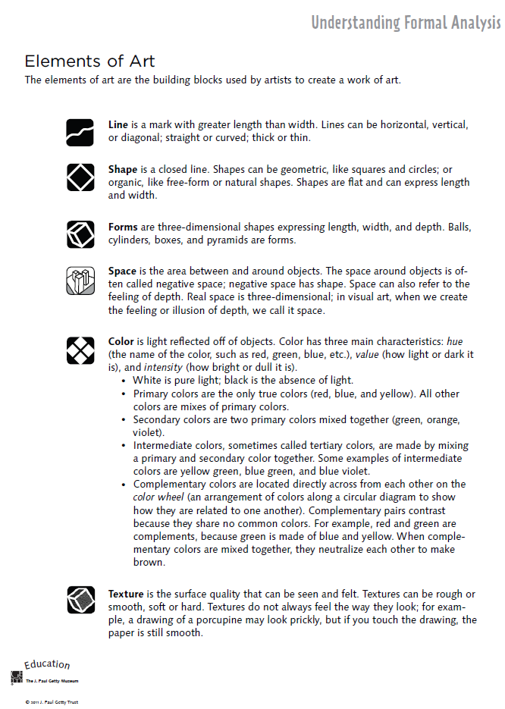

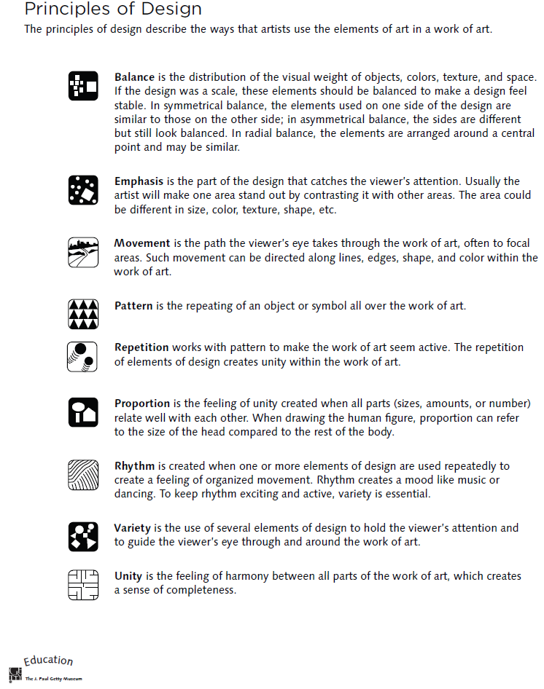

Four-Step Critical Analysis Process
- Step 1: Describe – What do you see?
  - Credit line information such as title, artist, date created, size, medium, location, genre.
  - What do you see in the art work? Use objective observations and identification skills. All descriptions must be observable facts.
  - EXAMPLE: “Starry Night, Vincent Van Gogh, 1832…I see a large cypress tree in the foreground. I can tell it is a cypress by the shape. The majority of the picture is taken up by a night sky. There are many stars in the sky. Etc….”
- Step 2: Analyze—How is the work organized?
  - Focus on how the Elements of Art and Principles of Design have been used in the artwork. You are still collecting clues, not guessing! How do the Principles organize the Elements? Use specific evidence from the art. This will help you discover how the artist might have created moods, messages, or ideas.
  - EXAMPLE: “The night sky is dark blue, and it is filled with vibrant yellow stars. The pattern of the stars moves the viewer’s eye back and forth throughout the painting. The repetition of the yellow into the village lights help give the picture unity. Etc….”
- Step 3: Interpret – “What is the artist saying?”
  - Using the information from the description and analysis, explain what the artist might be trying to communicate. What is the mood or the meaning of the artwork? Make some guesses and provide some evidence for your thinking using the Elements and Principles. Your interpretation might be different from someone else’s.
  - Answer the question, “I think________________, because I see __________________.”
  - EXAMPLE: “I think the artist is trying to show a connection between a sleepy peaceful mood and the quiet little town, because the artists uses the some colors and kinds of lines in the sky and the village. I see the colors and the soft, swirling lines in the sky, and it makes me think the artist was trying to show that even a dark sky can have lots to see. Etc….”
- Step 4: Judge – “Is this a successful piece of art?”
  - Now you can finally express your own personal opinion about the piece of art. Your opinion, however, is still based on what you’ve discovered through description, analysis, and interpretation, all backed up with visual evidence and the language of art. This is a carefully thought out decision in which you decided if the art was successful or not successful, not necessarily a like or dislike.
  - Answer this questions, “I think this work is (not) successful because _____________________.”
  - EXAMPLE: “I think this work is successful because it the colors and lines are organized in an interesting, swirly way that grabs my attention. The work is almost like a lullaby because the yellow stars twinkle in the sky like peaceful little notes over the sleepy town. Etc…

