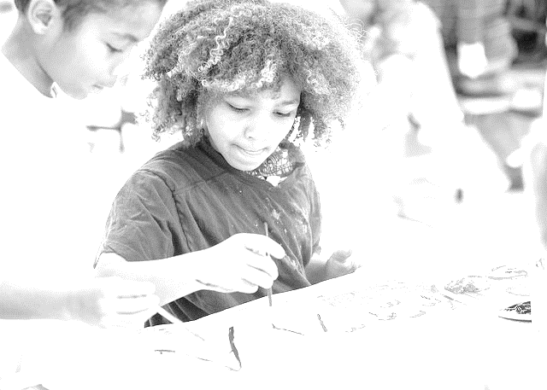

Middle School (Grades 6-8)
Visual Arts Curriculum Guide
© June, 2016

Visual Arts Curriculum, Instruction, and Assessment
2100 Fleur Drive | Des Moines, Iowa 50312 | P: 515-242-7619
visualarts.dmschools.org

Superintendent
Thomas Ahart, Ed.D
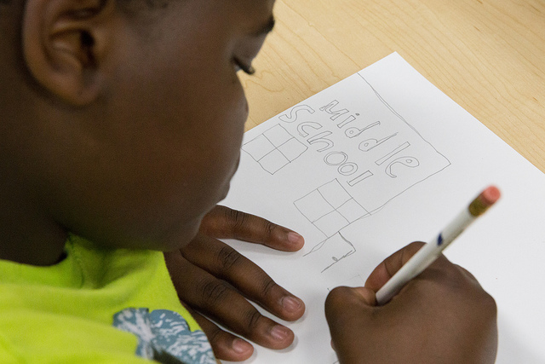
Executive Director of Secondary Teaching & Learning
Noelle Tichy
Visual Arts Curriculum Coordinator
Sarah Dougherty
Secondary Curriculum Lead Team Editors – Middle School
Derrick Ogden, Brody Middle School
Dawn Pinion, Weeks Middle School
Virginia Rogers, Hiatt Middle School
Diana Givens, McCombs Middle School
Secondary Curriculum Lead Team Editors – High School
Bryan Butcher, North High School
Sam Chiodo, Roosevelt High School
Michel Gude, Scavo Alternative High School
Samantha Jones-Tweedy, Future Pathways/ Gateway
Jason Soliday, East High School
Heather Worthington, Lincoln High School
Janet Murillo, Hoover High School

Foreword The curriculum in this document is based on the National Core Arts Standards published in the spring of 2014. It has been developed by visual art educators and curriculum specialists in the Des Moines Public Schools. The objectives in this curriculum guide are the minimum requirements in the visual arts that set rigorous, relevant, clear, and measurable learning targets and expectations for what teachers should teach and students should learn. Schools and educators are continuously encouraged to go beyond these targets to better serve the needs of all students in the visual arts.

Definition of the Visual Arts
Visual arts include the traditional fine arts such as drawing, painting, printmaking, photography, and sculpture; media arts including film, graphic communications, animation, and emerging technologies; architectural, environmental, and industrial arts such as urban, interior, product, and landscape design; folk arts; and works of art such as ceramics, fibers, jewelry, works in wood, paper, and other materials. –National Art Education Association
Table of Contents
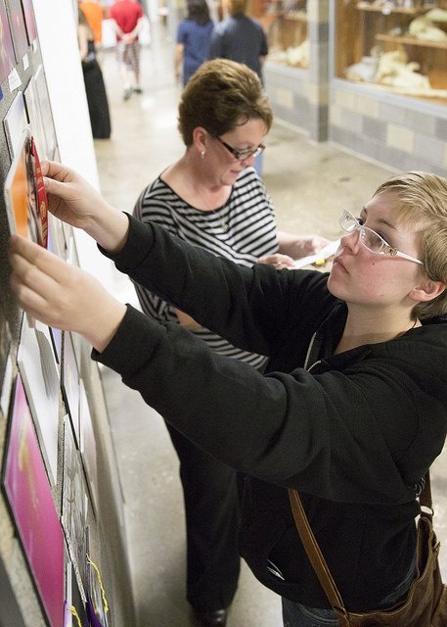
How to use this document…………………………………………………………………………..4
DMPS Philosophy and Objectives…………………………………………………………………5-6
Document Structures………………………………………………………………………………..7
Reporting Clusters………………………………………………………………………………..8-13
Design Concepts…………………………………………………………………………....8
Studio Skills………………………………………………………………………………....9
Critical Analysis……………………………………………………………………………..10
Making Connections………………………………………………………………………..12
Grade Level Scopes…………………………………………………………………………….....14-16
Sixth Grade………………………………………………………………………………....14
Seventh Grade……………………………………………………………………………....15
Eighth Grade…………………………………………………………………………....…..16
Assessment Rubric…………………………………………………………………………………...17
Common Vocabulary………………………………………………………………………………...18
Elements of Art…………………………………………………………………………………...…19
Principles of Design……………………………………………………………………………...…..20
Four-Step Critical Analysis Process……………………………………………………………..…....21
How to use this document:
This curriculum guide is not…
- A lock-step instructional guide detailing exactly when and how you teach.
- Meant to restrict your creativity as a teacher.
- A ceiling of what your students can learn, nor a set of unattainable goals.
Instead, the curriculum guide is meant to be a common vision for student learning and a set of standards by which to measure and report student progress and provide meaningful feedback.
The curriculum guide outlines which learning goals are most essential for student learning; it is our district’s guaranteed and viable curriculum. The expectation is that every student in our district, regardless of school or classroom, will know and understand these learning goals. As the classroom teacher, you should use the curriculum guide to help you to decide how to scaffold up to the learning goals, and extend your students’ learning beyond them.
The curriculum guide is a planning tool; assessed clusters and topics are provided, but as the instructional leader of your classroom, you determine the scope and sequence in which you will introduce the prioritized learning goals. You are encouraged to create your own sub-units of study within each cluster using the topics as a starting point. Within this document you will find a foundational structure for planning instruction in the visual arts which can be supplemented with unlimited materials from any number of sources, including but not limited to district texts and prints.
Please consider this guide a living and dynamic document, subject to change and a part of a continuous feedback loop. As part of this logic model, common task banks and district-wide common formative assessments are being generated during the 2014-2015 and 2015-2016 school years.

Des Moines Public Schools Educational Philosophy

Vision
Becoming the model for urban education in the United States.

Mission Statement
The Des Moines Public Schools Exist So That Graduates Possess the Knowledge, Skills and Abilities to Be Successful at the Next Stage of Their Lives.

Student Expectations
Students demonstrate proficiency and understanding of a rigorous core curriculum:
- They demonstrate proficiency in reading, writing, speaking and listening
- They demonstrate proficiency in mathematics, including algebra and geometry
- They demonstrate financial and economic literacy
- They demonstrate an understanding of the value of fine and performing arts in society
- They demonstrate proficiency in technological and information literacy
- They demonstrate proficiency in science, including life, earth and physical science

Students possess the knowledge and skills to be self-directed and autonomous:
- They demonstrate critical thinking and problem solving skills
- They exercise sound reasoning in making complex choices
- They exhibit creative, innovative and entrepreneurial thinking
- They understand the attributes of physical and mental well-being

Students have world awareness:
- They learn from and work with individuals representing diverse cultures and religions in a spirit of mutual respect in school, work and community
- They understand the rights and obligations of citizenship at local, state, national, and global levels
- They are actively engaged in community life
- They will be exposed to languages and cultures of the world

- Des Moines Public Schools K-12 Student Learning Objectives in the Visual Arts
  - Students can communicate at a foundational level in the visual arts. This includes knowledge and skills in the use of basic vocabularies, materials, tools, techniques, and intellectual methods of the discipline.
  - Students can communicate proficiently in at least one art form, including the ability to define and solve artistic problems with insight, reason, and technical proficiency.
  - Students can develop foundational evaluations and analyses of works of art from structural, historical, and cultural perspectives.
  - Students can develop an informed acquaintance with exemplary works of art from a variety of cultures and historical periods, and a basic understanding of historical development in the arts disciplines, across the arts as a whole, and within cultures.
- Effective Components of an Educational Studio Program
  - Demonstrations of artistic techniques and uses of media
  - Opportunities for practice, experimentation, and refinement based on effective feedback
  - Support for divergent thinking and multiple learning outcomes
  - A rich and robust variety of visual references
  - A variety of critique and response formats
  - Introductions to and expectations for use of appropriate art vocabulary
  - Connections among artists, careers, and art in everyday life and communities
  - An organizational system for storage and disbursement of materials and tools
  - Clear and maintained expectations for art room safety, cleaning, and classroom procedures
  - Integrations and connections with other content areas
  - Displays of various student works within the school and the community
- Learning Clusters for Grades 6-8
  - Design Concepts: Elements of Art and Principles of Design
  - Studio Skills: Media and Processes
  - Critical Analysis: Planning and Evaluating
  - Making Connections: Connecting to Contexts
Document Structures
Learning goals for all curricular areas are organized by overarching concepts called topics. Within those topics live a learning goal. All learning goals for the visual arts are guided by the 2014 National Visual Arts Standards and assessed on the provided reporting scales. The outline below serves to define the various elements of the curriculum structure.
- Learning Topic – The Overarching Concept
  - Definition of the topic.
  - National Standards alignments – those most closely related to the overarching concept.
    - Anchor Standard: Anchor standards define the expectations for students entering college and careers, and provide the foundation for the K-12 visual arts standards.
    - Enduring Understanding: Statements summarizing important ideas and core processes that are central to visual arts and have lasting value beyond the classroom. They synthesize what students should understand—not just know or do—as a result of studying visual arts.
    - Essential Questions: Organizing questions to set the focus for lessons or units. They are the initiators of creative and critical thinking.
Evidence of student learning is assessed on a four-point scale, common throughout the district. Scales are designed to measure each learning topic. The generalized scale, with student-friendly language included, is below.
SCALE SCORE | ACADEMIC DESCRIPTOR | STUDENT-FRIENDLY DESCRIPTOR
4 | Exceeding Standard | I have demonstrated deep understanding  that goes beyond the learning goal
3 | Meeting Standard | I have met the learning goal
2 | Developing Toward Standard | I have the foundational skills and knowledge  for the learning goal and I am almost there
1 | Insufficient Progress | The evidence I have submitted shows I have a  long way to go to reach the learning goal
0/M | No evidence of student understanding in submitted work OR  Missing – student has not submitted evidence | I have not submitted evidence of learning for the learning goal

*For more information on district assessment and grading practices, please refer to the Grading Practices website http://grading.dmschools.org/teacher-resources.html
- Reporting Cluster -- Design Concepts: Elements of Art and Principles of Design
  - The Elements of Art are defined as the visual components of color, form, line, shape, space, texture, and value.
  - National Standards alignments
    - Anchor Standard: Organize and develop artistic ideas and work.
    - Enduring Understanding: People create and interact with objects, places, and design that define, shape, enhance, and empower their lives.
    - Essential Questions: How do artists and designers create works of art or design that effectively communicate?
    - Grade-level student learning objectives/ task generators
      - 6th Grade – Design or redesign objects, places, or systems that meet the identified needs of diverse users.
      - 7th Grade – Apply visual organization strategies to design and produce a work of art that clearly communicates information or ideas.
      - 8th Grade – Select, organize, and design images and words to make visually clear and compelling presentations

- Assessment Scale
1 | 2 | 3 | 4
Student’s performance reflects insufficient progress towards foundational skills and knowledge. | Students will recognize or recall specific vocabulary including, but not limited to:  - Line, shape, forms, space, color, texture, balance, emphasis, movement, pattern, repetition, proportion, rhythm, variety, unity, composition, perspective, craftsmanship, portfolio, rubric, 2D/3D, technique, context, media  Students demonstrate they have developed the ability to:  - Identify and describe the Elements of Art and the Principles of Design. | Students demonstrate they have the ability to:  - Independently apply multiple Elements of Art to an original artwork.  - Independently apply multiple Principles of Design to an original artwork.  - Provide evidence for their artistic choices. | In addition to score 3.0 performance, students demonstrate in-depth inferences and applications that go beyond the learning target.

- Reporting Cluster – Studio Skills: Media and Processes
  - Artistic Media and Processes are defined as the means of expression (tools, materials, and techniques) used to produce a work of art.
  - New National Standards alignments
    - Anchor Standard: Organize and develop artistic ideas and work.
    - Enduring Understandings
      - Artists and designers experiment with forms, structures, materials, concepts, media, and art-making approaches.
      - Artists and designers balance experimentation and safety, freedom and responsibility, while developing and creating art
    - Essential Questions
      - How do artists work?
      - How do artists care for and maintain materials, tools, and equipment?
      - What responsibilities come with the freedom to create?
    - Grade-level student learning objectives/ task generators
      - 6th Grade
        - Demonstrate openness in trying new ideas, materials, methods, and approaches in making art.
        - Demonstrate quality craftsmanship through care for and use of materials, tools, and equipment.
      - 7th Grade -- Demonstrate persistence in developing skills with various materials and methods in making art.
      - 8th Grade – Demonstrate willingness to experiment, innovate, and take risks to pursue ideas in art making
- Assessment Scale
1 | 2 | 3 | 4
Student’s performance reflects insufficient progress towards foundational skills and knowledge. | Students will recognize or recall specific vocabulary including, but not limited to:  - Craftsmanship, portfolio, technique, media  Students demonstrate they have developed the ability to:  - Identify and describe the intended uses of media and tools.  - Identify and describe artistic processes and techniques. | Students demonstrate they have the ability to:  - Apply intended uses of media and tools in an artistic process or technique to create an original artwork.  - Provide evidence for their artistic choices. | In addition to score 3.0 performance, students demonstrate in-depth inferences and applications that go beyond the learning target.

- Reporting Cluster – Critical Analysis: Planning and Evaluating
  - Planning is defined as the process of conceiving and developing new artistic ideas and work.
  - Evaluating is defined as judging the merits or value of a piece of art based on a set of criteria.
  - New National Standards alignments
    - Anchor Standard:
      - Generate and conceptualize artistic ideas and work.
      - Refine and complete artistic work.
      - Apply criteria to evaluate artistic work.
    - Enduring Understandings
      - Creativity and innovative thinking are essential life skills that can be developed.
      - Artists and designers shape artistic investigations, following or breaking with traditions, in pursuit of creative goals.
      - Artists and designers develop excellence through practice and constructive critique, reflecting on, revising, and refining work over time.
      - People gain insights into meanings of artworks by engaging in the process of art criticism.
      - People evaluate art based on various criteria.
    - Essential Questions
      - What conditions, attitudes, and behaviors support creativity and innovative thinking?
      - What factors prevent or encourage people to take creative risks?
      - How does collaboration expand the creative process?
      - How does collaboratively reflecting on work help us experience it more fully and develop it more completely?
      - How does the viewer “read” a work of art?
      - How is personal preference different from an evaluation?
    - Grade-level student learning objectives/ task generators
      - 6th Grade
        - Collaboratively combine concepts to generate an innovative idea for art making.
        - Formulate an artistic investigation of personally relevant content for creating art.
        - Reflect on whether one’s artwork conveys the intended meaning and revise accordingly.
        - Interpret art by analyzing subject matter and characteristics of structure to identify moods or ideas.
        - Develop and apply relevant criteria to evaluate a work of art.
      - 7th Grade
        - Apply methods to overcome creative blocks.
        - Develop criteria to guide making a work of art or design to meet an identified goal.
        - Reflect on and explain important information about personal artwork in an artist statement.
        - Interpret art by analyzing art-making approaches, subject matter, and characteristics of structure to identify moods or ideas.
        - Compare and explain evaluation based on personal criteria versus an established set of criteria.
      - 8th Grade
        - Document early stages of the creative process visually and/or verbally in traditional or new media.
        - Collaboratively shape an artistic investigation of an aspect of contemporary life using a contemporary practice of art or design
        - Apply relevant criteria to examine, reflect on, and plan revisions for a work of art or design in progress.
        - Interpret are by analyzing the how the interaction of art-making approaches, subject matter, and characteristics of structure contributes to understanding moods or ideas.
        - Create a convincing and logical argument to support an evaluation of a work of art.

- Assessment Scale (Planning and Evaluating)
1 | 2 | 3 | 4
Student’s performance reflects insufficient progress towards foundational skills and knowledge. | Students will recognize or recall specific vocabulary including, but not limited to:  - Composition, perspective, media  Students demonstrate they have developed the ability to:  - Formulate and communicate and action plan.  - Formulate and convey a response to their own artwork and the work of others. | Students demonstrate they have the ability to:  - Formulate, communicate, and implement an action plan, making appropriate adjustments.  - Critically analyze and evaluate their own work or the work of others based on established criteria.  - Collaborate with peers or other learning partners. | In addition to score 3.0 performance, students demonstrate in-depth inferences and applications that go beyond the learning target.

- Reporting Cluster – Making Connections: Connecting to Contexts
  - Connecting to Contexts is defined as exploring links between works of art and history, society, culture, and personal experiences.
  - New National Standards alignments
    - Anchor Standard
      - Perceive and analyze artistic work.
      - Relate artistic ideas and works with societal, cultural, and historical context to deepen understanding.
      - Synthesize and relate knowledge and personal experiences to make art.
    - Enduring Understandings
      - Engagement with art can lead to understanding and appreciation of self, others, the natural world, and constructed environments.
      - People develop ideas and understandings of society, culture, and history through their interactions with and analyses of art.
    - Essential Questions
      - How do life experiences influence the way you relate to art?
      - How does art help us understand the lives of people of different times, places, and cultures?
      - How is art used to impact the views of society?
    - Grade-level student learning objectives/ task generators
      - 6th Grade
        - Identify and interpret works of art or design that reveal ways people live around the world and what they value.
        - Analyze how art reflects changing times, traditions, resources, and cultural issues.
        - Generate a collection of ideas reflecting current interests and concerns that could be investigated in art making.
      - 7th Grade
        - Analyze how response to art is influenced by understanding the time and place which it was created.
        - Create visual documentation of places and times in which people gather to make or experience art.
      - 8th Grade
        - Explain how an individual’s aesthetic choices are influenced by culture and environment.
        - Distinguish different ways art is used to represent, establish, reinforce, and reflect group identity.
        - Collaboratively make art to reflect on and reinforce positive aspects of group identity.

- Assessment Scale (Connecting to Contexts)
1 | 2 | 3 | 4
Student’s performance reflects insufficient progress towards foundational skills and knowledge. | Students will recognize or recall specific vocabulary such as:  - Context  Students demonstrate they have developed the ability to:  - Identify contextual elements from history, cultures, artistic movements, and society in the work of others. | Students demonstrate they have the ability to:  - Apply contextual elements from history, cultures, artistic movements, and society to their own artwork. | In addition to score 3.0 performance, students demonstrate in-depth inferences and applications that go beyond the learning target.

Grade Level Scope – Sixth Grade
Use these National Standards aligned student objectives to design instruction and generate tasks with the aim of meeting the learning targets outlined on the district assessment scales.
- Design Concepts: Elements of Art and Principles of Design
  - Design or redesign objects, places, or systems that meet the identified need of diverse users.
- Studio Skills: Media and Processes
  - Demonstrate openness in trying new ideas, materials, methods, and approaches in making art.
  - Demonstrate quality craftsmanship through care for and use of materials, tools, and equipment.
- Critical Analysis: Planning and Evaluating
  - Collaboratively combine concepts to generate an innovative idea for art making.
  - Formulate an artistic investigation of personally relevant content for creating art.
  - Reflect on whether one’s artwork conveys the intended meaning and revise accordingly.
  - Interpret art by analyzing subject matter and characteristics of structure to identify moods or ideas.
  - Develop and apply relevant criteria to evaluate a work of art.
- Making Connections: Connecting to Contexts
  - Identify and interpret works of art or design that reveal ways people live around the world and what they value.
  - Analyze how art reflects changing times, traditions, resources, and cultural issues.
  - Generate a collection of ideas reflecting current interests or concerns that could be investigated in art making.

Grade Level Scope – Seventh Grade
Use these National Standards aligned student objectives to design instruction and generate tasks with the aim of giving students multiple opportunities to meet the learning targets outlined on the district assessment scales.
- Design Concepts: Elements of Art and Principles of Design
  - Apply visual organization strategies to design and produce a work of art that clearly communicates information or ideas.
- Studio Skills: Media and Processes
  - Demonstrate persistence in developing skills with various materials and methods in making art.
- Critical Analysis: Planning and Evaluating
  - Apply methods to overcome creative blocks.
  - Develop criteria to guide making a work of art or design to meet an identified goal.
  - Reflect on and explain important information about personal artwork in an artist statement.
  - Interpret art by analyzing art making approaches, subject matter, and characteristics of structure to identify moods or ideas.
  - Compare and explain evaluation based on personal criteria versus an established set of criteria.
- Making Connections: Connecting to Contexts
  - Analyze how response to art is influenced by understanding the time and place which it was created.
  - Create visual documentation of places and times in which people gather to make or experience art.

Grade Level Scope – Eighth Grade
Use these National Standards aligned student objectives to design instruction and generate tasks with the aim of meeting the learning targets outlined on the district assessment scales.
- Design Concepts: Elements of Art and Principles of Design
  - Select, organize, and design images and words to make visually clear and compelling presentations.
- Studio Skills: Media and Processes
  - Demonstrate willingness to experiment, innovate, and take risks to pursue ideas in art making.
- Critical Analysis: Planning and Evaluating
  - Document early stages of the creative process visually and/or verbally in traditional or new media.
  - Collaboratively shape an artistic investigation of an aspect of contemporary life using a contemporary practice of art or design.
  - Apply relevant criteria to examine, reflect on, and plan revisions for a work of art or design in progress.
  - Interpret are by analyzing the how the interaction of art-making approaches, subject matter, and characteristics of structure contributes to understanding moods or ideas.
  - Create a convincing and logical argument to support an evaluation of a work of art.
- Making Connections: Connecting to Contexts
  - Explain how an individual’s aesthetic choices are influenced by culture and environment.
  - Distinguish different ways art is used to represent, establish, reinforce, and reflect group identity.
  - Collaboratively make art to reflect on and reinforce positive aspects of group identity.

Cluster: Topic | 1 | 2 | 3 | 4
 | Insufficient Progress | Developing Toward Standard | Meeting Standard | Exceeding Standard
Design Concepts: Elements of Art and Principles of Design | Student’s performance reflects insufficient progress towards foundational skills and knowledge. | Students will recognize or recall specific vocabulary including, but not limited to:  - Line, shape, forms, space, color, texture, balance, emphasis, movement, pattern, repetition, proportion, rhythm, variety, unity, composition, perspective, craftsmanship, portfolio, rubric, 2D/3D, technique, context, media  Students demonstrate they have developed the ability to:  - Identify and describe the Elements of Art and the Principles of Design. | Students demonstrate they have the ability to:  - Independently apply multiple Elements of Art to an original artwork.  - Independently apply multiple Principles of Design to an original artwork.  - Provide evidence for their artistic choices. | In addition to score 3.0 performance, students demonstrate in-depth inferences and applications that go beyond the learning target.
Studio Skills: Media and Processes | Student’s performance reflects insufficient progress towards foundational skills and knowledge. | Students will recognize or recall specific vocabulary including, but not limited to:  - Craftsmanship, portfolio, technique, media  Students demonstrate they have developed the ability to:  - Identify and describe the intended uses of media and tools.  - Identify and describe artistic processes and techniques. | Students demonstrate they have the ability to:  - Apply intended uses of media and tools to an artistic process or technique to create an original artwork.  - Provide evidence for their artistic choices. | In addition to score 3.0 performance, students demonstrate in-depth inferences and applications that go beyond the learning target.
Critical Analysis: Planning and Evaluating | Student’s performance reflects insufficient progress towards foundational skills and knowledge. | Students will recognize or recall specific vocabulary including, but not limited to:  - Composition, perspective, media  Students demonstrate they have developed the ability to:  - Formulate and communicate and action plan.  - Formulate and convey a response to their own artwork and the work of others. | Students demonstrate they have the ability to:  - Formulate, communicate, and implement an action plan, making appropriate adjustments.  - Critically analyze and evaluate their own work or the work of others based on established criteria.  - Collaborate with peers or other learning partners. | In addition to score 3.0 performance, students demonstrate in-depth inferences and applications that go beyond the learning target.
Making Connections: Connecting to Contexts | Student’s performance reflects insufficient progress towards foundational skills and knowledge. | Students will recognize or recall specific vocabulary including, but not limited to:  - Context  Students demonstrate they have developed the ability to:  - Identify contextual elements from history, cultures, artistic movements, and society in the work of others. | Students demonstrate they have the ability to:  - Apply contextual elements from history, cultures, artistic movements, and society to their own artwork. | In addition to score 3.0 performance, students demonstrate in-depth inferences and applications that go beyond the learning target.
Common Vocabulary Terms
Common vocabulary for selected media, styles, art movements, and art expressions reflect the concepts, techniques, and skills for each grade level and course of study. Students will use these terms in oral, written, and visual communications. Teachers are encouraged to provide additional visual arts vocabulary to the identified lists.
Required Terms |  |  | Recommended Terms
- Line  - Shape  - Forms  - Space  - Color  - Texture | - Balance  - Emphasis  - Movement  - Pattern  - Repetition  - Proportion  - Rhythm  - Variety  - Unity | - Composition  - Perspective  - Craftsmanship  - Portfolio  - Technique  - Context  - Media  - Critique | - Horizontal  - Vertical  - Diagonal  - Geometric  - Organic  - Length  - Width  - Depth  - Negative Space  - Positive Space | - Hue  - Value  - Intensity  - Primary  - Secondary  - Tertiary  - Complimentary  - Surface  - Scale  - Symmetry  - Asymmetry | - Contrast  - Focal Point  - Symbol  - Mood  - Harmony

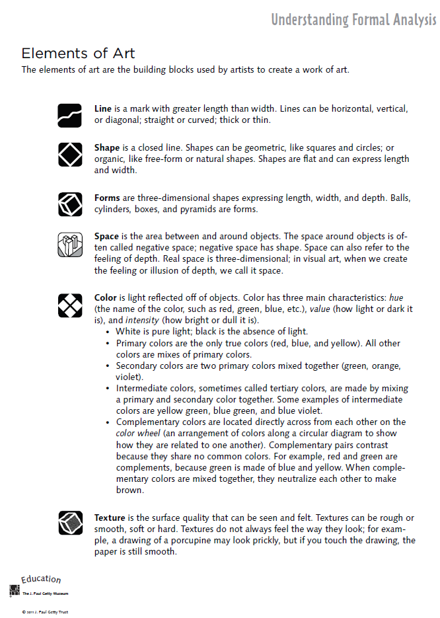

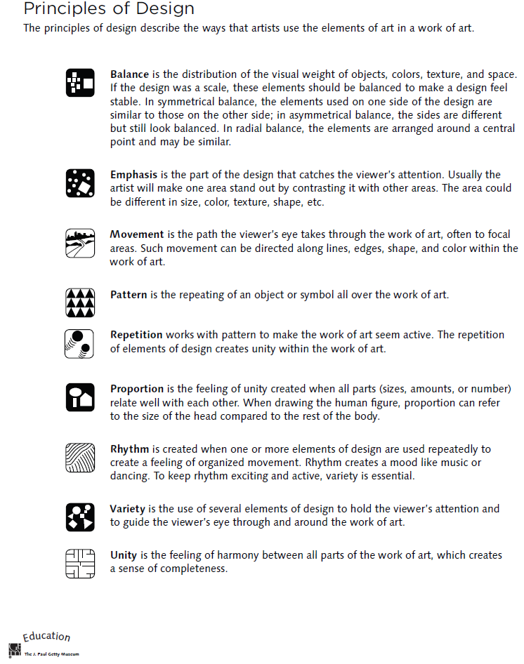
Four-Step Critical Analysis Process
- Step 1: Describe – What do you see?
  - Credit line information such as title, artist, date created, size, medium, location, genre.
  - What do you see in the art work? Use objective observations and identification skills. All descriptions must be observable facts.
  - EXAMPLE: “Starry Night, Vincent Van Gogh, 1832…I see a large cypress tree in the foreground. I can tell it is a cypress by the shape. The majority of the picture is taken up by a night sky. There are many stars in the sky. Etc….”
- Step 2: Analyze—How is the work organized?
  - Focus on how the Elements of Art and Principles of Design have been used in the artwork. You are still collecting clues, not guessing! How do the Principles organize the Elements? Use specific evidence from the art. This will help you discover how the artist might have created moods, messages, or ideas.
  - EXAMPLE: “The night sky is dark blue, and it is filled with vibrant yellow stars. The pattern of the stars moves the viewer’s eye back and forth throughout the painting. The repetition of the yellow into the village lights help give the picture unity. Etc….”
- Step 3: Interpret – “What is the artist saying?”
  - Using the information from the description and analysis, explain what the artist might be trying to communicate. What is the mood or the meaning of the artwork? Make some guesses and provide some evidence for your thinking using the Elements and Principles. Your interpretation might be different from someone else’s.
  - Answer the question, “I think________________, because I see __________________.”
  - EXAMPLE: “I think the artist is trying to show a connection between a sleepy peaceful mood and the quiet little town, because the artists uses the some colors and kinds of lines in the sky and the village. I see the colors and the soft, swirling lines in the sky, and it makes me think the artist was trying to show that even a dark sky can have lots to see. Etc….”
- Step 4: Judge – “Is this a successful piece of art?”
  - Now you can finally express your own personal opinion about the piece of art. Your opinion, however, is still based on what you’ve discovered through description, analysis, and interpretation, all backed up with visual evidence and the language of art. This is a carefully thought out decision in which you decided if the art was successful or not successful, not necessarily a like or dislike.
  - Answer this questions, “I think this work is (not) successful because _____________________.”
  - EXAMPLE: “I think this work is successful because it the colors and lines are organized in an interesting, swirly way that grabs my attention. The work is almost like a lullaby because the yellow stars twinkle in the sky like peaceful little notes over the sleepy town. Etc….

